## ДОПОЛНИТЕЛЬНЫЕ МАТЕРИАЛЫ

Подписи к рис. S1–S2. cт. Ю.А. Зуева и др.

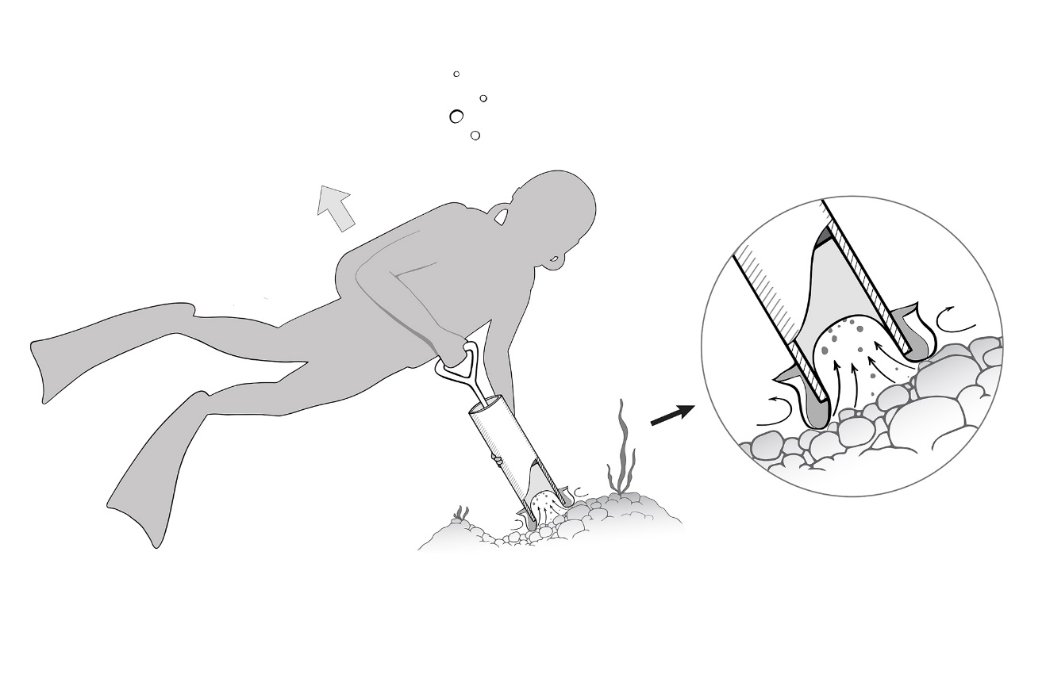

Рис. S1. Схема работы поршневого пробоотборника.

Fig. S1. Scheme of operation of a piston sampler.

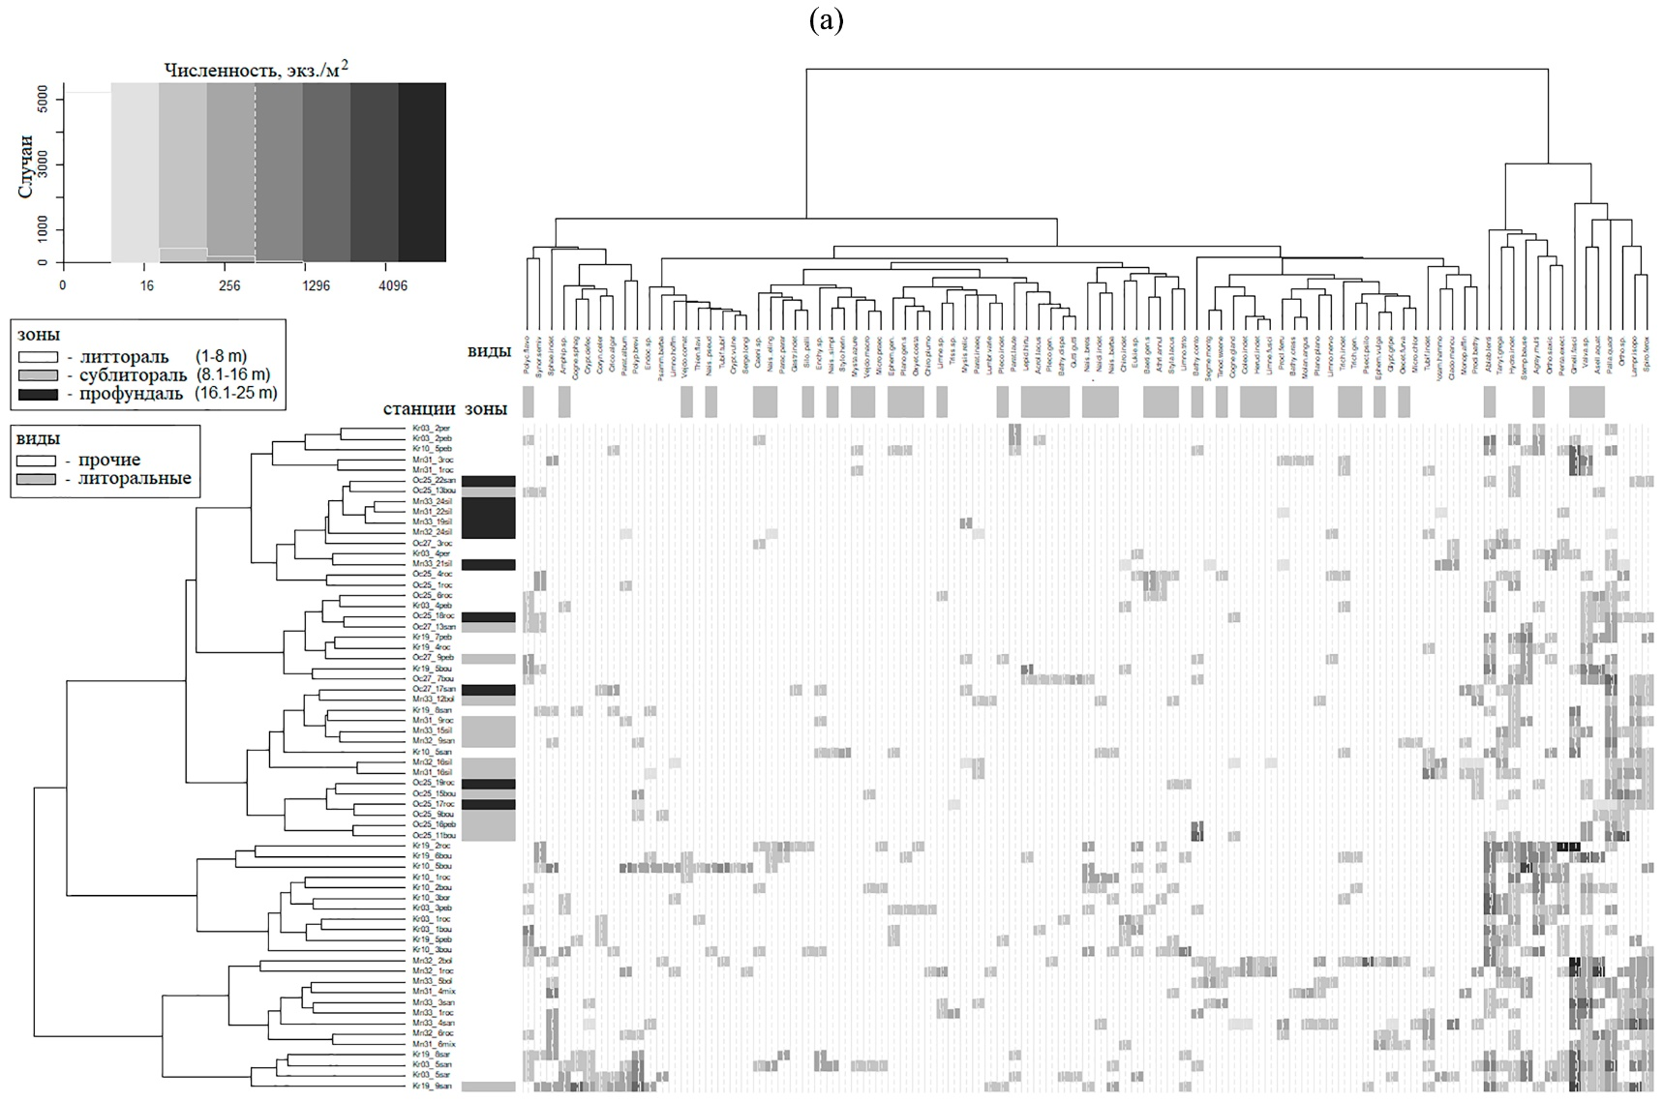

а)

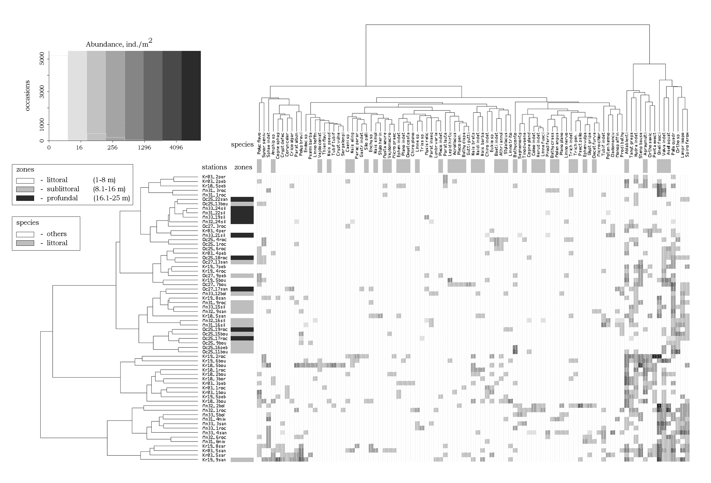

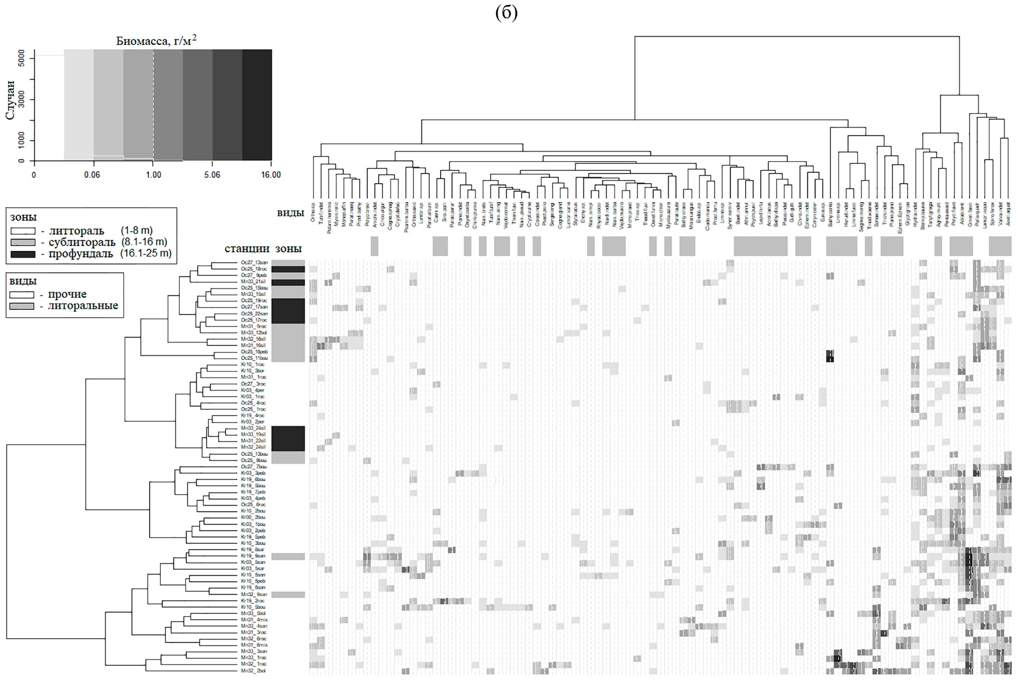

б)

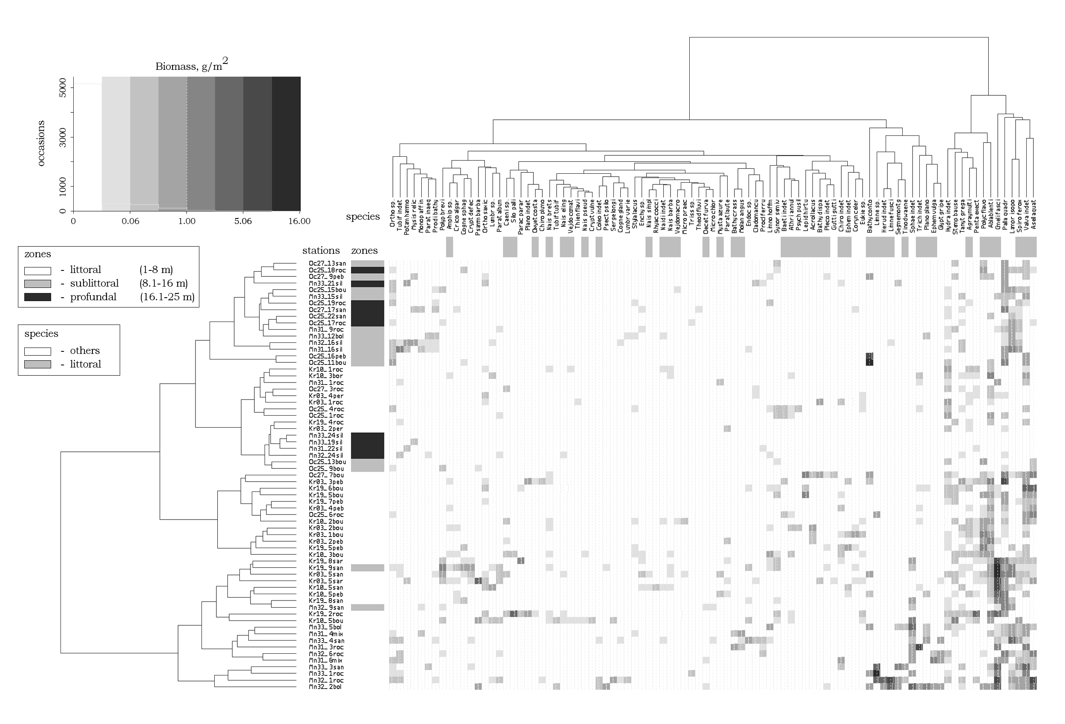

Рис. S2. Тепловая карта, построенная на основании корня четверной степени из численности (а) и биомассы (б) зообентоса на станциях заливов о. Валаам.

Цветовая легенда обозначает численность или биомассу таксона на станции от отсутствия таксона (белый цвет) до максимальных значений (темно-серый). Коды названий станций: Kr (в **Kr**19_ 1bou), Kr – бухта Крестового залива, Mn – Малая Никоновская бухта, Oc – открытое побережье Крестового залива, 19 (в Kr**19**_ 1bou) – номера трансекты; 13 (в Kr19_**13**bou) – глубина на станции, метры; bou (в Kr19_ 1**bou**) – грунт (соответственно roc – скалы, bou – валуны, peb – галька, mix – валуны с песком, san – песок, sil – ил); r (в Kr19_ 2bo**r**, исключая si**l**) – берег залива (r – правый, l – левый). Обозначение таксонов: *Cogne gland – Cognettia glandulosa, Cogne sphag – Cognettia sphagnetorum, Enchy* sp. *– Enchytraeidae* sp., *Lampr isopo – Lamprodrilus isoporus, Limno hoffm – Limnodrilus hoffmeisteri, Lumbr sp. – Lumbriculidae sp., Lumbr varie – Lumbriculus variegatus, Naidi indet – Naididae indet, Nais barba – Nais barbata, Nais brets – Nais bretscheri, Nais eling – Nais elinguis, Nais pseud – Nais pseudobtusa, Nais simpl – Nais simplex, Potam hammo – Potamothrix hammoniensis, Psamm barba – Psammoryctides barbatus, Rhyac cocci – Rhyacodrilus coccineus, Spiro ferox – Spirosperma ferox, Styla lacus – Stylaria lacustris, Stylo herin – Stylodrilus heringianus, Tubif tubif – Tubifex tubifex, Tubif indet – Tubificidae indet, Vejdo macro – Vejdovskyella macrochaeta, Vejdo comat – Vejdovskyella comata,* Herud indet – Herudinea indet,Sphae indet – Sphaeriidae indet, *Acrol lacus – Acroloxus lacustris, Bathy conto – Bathyomphalus contortus, Bathy crass – Bathyomphalus crassus, Bathy dispa – Bathyomphalus dispar,* Gastr indet – Gastropoda indet,Plano indet – Planorbidae indet., *Plano plano – Planorbis planorbis, Segme montg – Segmentina montgazoniana, Theod fluvi – Theodoxus fluviatilis, Valva indet. – Valvatidae indet*., *Asell aquat – Asellus aquaticus,* Amphip sp. – Amphipoda sp. juv., *Gmeli fasci – Gmelinoides fasciatus, Monop affin – Monoporeia affinis, Palla quadr – Pallaseopsis quadrispinosa, Mysis relic – Mysis relicta, Baeti* indet. *– Baetidae* indet., *Caeni* sp. *– Caenis* sp.*, Ephem vulga – Ephemera vulgata,* Ephem indet – Ephemeroptera indet., Pleco indet – Plecoptera indet., Pleco gen. – Plecoptera gen. juv. sp.,Coleo indet – Coleoptera indet, *Agray multi – Agraylea multipunctata, Athri annul – Athripsodes annulicornis, Lepid hirtu – Lepidostoma hirtum, Limne fusci – Limnephilus fuscicornis, Limne* sp. *– Limnephilus sp., Molan angus – Molanna angustata, Mysta azure – Mystacides azureus, Oecet furva – Oecetis furva, Oxyet costa – Oxyethira costalis, Polyc flavo – Polycentropus flavomaculatus, Psych pusil – Psychomyia pusilla, Silo palli – Silo pallipes, Tinod waene – Tinodes waeneri,* Trich indet – Trichoptera indet, *Ablab lenti – Ablabesmyia lentiginosa*,Chiro indet – Chironomidae indet, *Chiro plumo – Chironomus plumosus, Clado mancu – Cladotanytarsus mancus, Coryn celer – Corynoneura celeripes, Crico algar – Cricotopus algarum, Crypt defec – Cryptochironomus defectus, Crypt vulne – Cryptochironomus vulneratus, Endoc* sp. *– Endochironomus* sp., *Eukie* sp. *– Eukiefferiella* sp., *Glypt gripe – Glyptotendipes gripekoveni, Gutti gutti – Guttipelopia guttipennis, Limno nervo – Limnochironomus nervosus, Limno sp. – Limnochironomus sp., Limno trito – Limnochironomus tritomis, Micro praec – Micropsectra praecox, Micro chlor – Microtendipes chloris*, Ortho sp. – Orthocladinae sp., *Ortho saxic – Orthocladius saxicola, Parac parar – Parachironomus pararostratus, Parat laute – Paratanytarsus lauterborni, Parat album – Paratendipes albumanus, Parat inaeq – Paratrichocladius inaequalis, Penta exect – Pentapedilum exectum, Polyp brevi – Polypedilum breviantennatum, Procl ferru – Procladius ferrugineus, Prodi bathy – Prodiamesa bathyphila, Psect psilo – Psectrocladius psilopterus, Serge longi – Sergentia longiventris, Stemp bause – Stempellina bausei, Synor semiv – Synorthocladius semivirens, Tanyt grega – Tanytarsus gregarius, Thien flavi – Thienemanniella flaviforceps, Triss* sp. *– Trissocladius* sp., *Hydra indet – Hydra* *indet.*

Fig. S2. The heat map based on the fourth root of the abundance (a) and biomass (b) of zoobenthos at stations in the bays of the Valaam island.

The color legend indicates the abundance or biomass of a taxon at a station from no taxon (white) to maximum values (dark gray). Station name codes: Kr (in **Kr**19_ 1bou), Bays: where Kr – Krestovoy Bay, Mn – Malaya Nikonovskaya Bay, Oc – open coast of Krestovoy Bay, 19 (in Kr**19**_ 1bou) – transect numbers; 13 (in Kr19_**13**bou) – depth at the station, m; bou (in Kr19_ 1**bou**) – ground (respectively: roc – rocks, bou – boulders, peb – pebbles, mix – boulders with sand, san – sand, sil – silt); r (in Kr19_ 2bo**r**, excluding sil) – the banks of the bay (r – right, l – left). Taxa designation:: *Cogne gland – Cognettia glandulosa, Cogne sphag – Cognettia sphagnetorum, Enchy* sp. *– Enchytraeidae* sp., *Lampr isopo – Lamprodrilus isoporus, Limno hoffm – Limnodrilus hoffmeisteri, Lumbr sp. – Lumbriculidae sp., Lumbr varie – Lumbriculus variegatus, Naidi indet – Naididae indet, Nais barba – Nais barbata, Nais brets – Nais bretscheri, Nais eling – Nais elinguis, Nais pseud – Nais pseudobtusa, Nais simpl – Nais simplex, Potam hammo – Potamothrix hammoniensis, Psamm barba – Psammoryctides barbatus, Rhyac cocci – Rhyacodrilus coccineus, Spiro ferox – Spirosperma ferox, Styla lacus – Stylaria lacustris, Stylo herin – Stylodrilus heringianus, Tubif tubif – Tubifex tubifex, Tubif indet – Tubificidae indet, Vejdo macro – Vejdovskyella macrochaeta, Vejdo comat – Vejdovskyella comata,* Herud indet – Herudinea indet,Sphae indet – Sphaeriidae indet, *Acrol lacus – Acroloxus lacustris, Bathy conto – Bathyomphalus contortus, Bathy crass – Bathyomphalus crassus, Bathy dispa – Bathyomphalus dispar,* Gastr indet – Gastropoda indet,Plano indet – Planorbidae indet., *Plano plano – Planorbis planorbis, Segme montg – Segmentina montgazoniana, Theod fluvi – Theodoxus fluviatilis, Valva indet. – Valvatidae indet*., *Asell aquat – Asellus aquaticus,* Amphip sp. – Amphipoda sp. juv., *Gmeli fasci – Gmelinoides fasciatus, Monop affin – Monoporeia affinis, Palla quadr – Pallaseopsis quadrispinosa, Mysis relic – Mysis relicta, Baeti* indet. *– Baetidae* indet., *Caeni* sp. *– Caenis* sp.*, Ephem vulga – Ephemera vulgata,* Ephem indet – Ephemeroptera indet., Pleco indet – Plecoptera indet., Pleco gen. – Plecoptera gen. juv. sp.,Coleo indet – Coleoptera indet, *Agray multi – Agraylea multipunctata, Athri annul – Athripsodes annulicornis, Lepid hirtu – Lepidostoma hirtum, Limne fusci – Limnephilus fuscicornis, Limne* sp. *– Limnephilus sp., Molan angus – Molanna angustata, Mysta azure – Mystacides azureus, Oecet furva – Oecetis furva, Oxyet costa – Oxyethira costalis, Polyc flavo – Polycentropus flavomaculatus, Psych pusil – Psychomyia pusilla, Silo palli – Silo pallipes, Tinod waene – Tinodes waeneri,* Trich indet – Trichoptera indet, *Ablab lenti – Ablabesmyia lentiginosa*,Chiro indet – Chironomidae indet, *Chiro plumo – Chironomus plumosus, Clado mancu – Cladotanytarsus mancus, Coryn celer – Corynoneura celeripes, Crico algar – Cricotopus algarum, Crypt defec – Cryptochironomus defectus, Crypt vulne – Cryptochironomus vulneratus, Endoc* sp. *– Endochironomus* sp., *Eukie* sp. *– Eukiefferiella* sp., *Glypt gripe – Glyptotendipes gripekoveni, Gutti gutti – Guttipelopia guttipennis, Limno nervo – Limnochironomus nervosus, Limno sp. – Limnochironomus sp., Limno trito – Limnochironomus tritomis, Micro praec – Micropsectra praecox, Micro chlor – Microtendipes chloris*, Ortho sp. – Orthocladinae sp., *Ortho saxic – Orthocladius saxicola, Parac parar – Parachironomus pararostratus, Parat laute – Paratanytarsus lauterborni, Parat album – Paratendipes albumanus, Parat inaeq – Paratrichocladius inaequalis, Penta exect – Pentapedilum exectum, Polyp brevi – Polypedilum breviantennatum, Procl ferru – Procladius ferrugineus, Prodi bathy – Prodiamesa bathyphila, Psect psilo – Psectrocladius psilopterus, Serge longi – Sergentia longiventris, Stemp bause – Stempellina bausei, Synor semiv – Synorthocladius semivirens, Tanyt grega – Tanytarsus gregarius, Thien flavi – Thienemanniella flaviforceps, Triss* sp. *– Trissocladius* sp., *Hydra indet – Hydra* *indet.*

**Таблица S1.** Численность (N, экз./м2) и биомасса (В, г/м2) зообентоса на разрезах через бухту Малая Никоновская

**Table S1.** Zoobenthos number (N, ind./m2) and biomass (В, g/m2) of transects in Malaia Nikonovskay Bay

|  |  |  |  |  |  |  |  |  |  |  |  |  |  |  |  |  |  |
| --- | --- | --- | --- | --- | --- | --- | --- | --- | --- | --- | --- | --- | --- | --- | --- | --- | --- |
| Ст. №№  St  №№ | Грунт  Ground | H, м  H, m | J, ° | Группы организмов/The groups of taxa | | | | | | | | | | | | Всего  Total | |
| Oligochaeta | | Chironomidae | | Mollusca | | Trichoptera | | Crustacea | | Другие Other | |
| N | B | N | B | N | B | N | B | N | B | N | B | N | B |
| Разрез 31 / Transect 31 | | | | | | | | | | | | | | | | | | |
| 1 | Скала/ Rock | 1 | 44.4 | 64 | 0.02 | – | – | 255 | 0.15 | 191 | 0.34 | 1782 | 0.35 | 64 | 0.05 | 2356 | 0.91 |
| 2 | Обломки скалы  Fragments of rock | 3 | 30.0 | – | – | 64 | 0.05 | 1146 | 2.65 | 191 | 7.74 | 1846 | 2.25 | – | – | 3247 | 12.69 |
| 3 | Песок, камни  Sand, boulders | 4.5 | 25.2 | 509 | 0.62 | 573 | 0.25 | 1146 | 2.42 | 191 | 0.63 | 700 | 0.21 | – | – | 3119 | 4.13 |
| 4 | Песок, камни  Sand, boulders | 6 | 34.8 | 127 | 0.23 | 255 | 1.15 | 318 | 0.57 | 64 | 0.01 | 573 | 1.52 | 255 | 1.15 | 1592 | 4.63 |
| 5 | Скала/ Rock | 9 | 34.8 | 318 | 0.63 | 382 | 0.28 | – | – | – | – | 509 | 0.33 | 64 | 0.03 | 1273 | 1.27 |
| 6 | Ил/Silt | 17 | 19.4 | 1260 | 3.74 | 440 | 0.31 | – | – | – | – | 300 | 0.68 | 40 | 0.05 | 2040 | 4.78 |
| 7 | Жидкий ил  Liquid silt | 22 | 4.3 | 20 | 0.08 | 60 | 0.03 | – | – | – | – | – | – | – | – | 80 | 0.11 |
| Разрез 32 / Transect 32 | | | | | | | | | | | | | | | | | | |
| 1 | Скала/ Rock | 1 | 31.7 | 955 | 1.13 | 1591 | 1.15 | 509 | 1.02 | 637 | 9.89 | 5729 | 13.81 | 573 | 3.42 | 9994 | 30.42 |
| 2 | Валуны/ Boulders | 2.4 | 44.4 | 1018 | 2.06 | 2546 | 2.25 | 700 | 8.68 | 382 | 5.13 | 7065 | 7.03 | 446 | 1.91 | 12157 | 27.06 |
| 3 | Скала/ Rock | 5.8 | 36.9 | 382 | 0.31 | 318 | 0.85 | 382 | 1.06 | 64 | 0.06 | 1018 | 2.72 | 127 | 0.26 | 2291 | 5.26 |
| 4 | Илистый песок/ Silty sand | 8.8 | 9.8 | 127 | 0.32 | 255 | 0.05 | 127 | 0.57 | 64 | 0.01 | 891 | 1.81 | 64 | 0.01 | 1528 | 2.77 |
| 5 | Илистый песок/ Silty sand | 15.5 | 14.5 | 600 | 1.36 | 480 | 0.46 | – | – | 13 | 0.01 | 80 | 0.71 | – | – | 1173 | 2.54 |
| 6 | Жидкий ил  Liquid silt | 23.9 | 3.1 | 160 | 0.23 | 240 | 0.09 | – | – | – | – | 20 | 0.03 | – | – | 420 | 0.35 |
| Разрез 33 / Transect 33 | | | | | | | | | | | | | | | | | | |
| 1 | Скала/ Rock | 1 | 12.5 | 700 | 0.15 | 382 | 0.20 | 1082 | 3.31 | 127 | 9.87 | 637 | 1.22 | 64 | 0.01 | 2992 | 14.76 |
| 2 | Песок/ Sand | 3.1 | 7.0 | 637 | 0.76 | 509 | 0.38 | 1464 | 3.83 | 255 | 4.65 | 1846 | 3.77 | 191 | 0.04 | 4902 | 13.43 |
| 3 | Песок/ Sand | 3.5 | 17.5 | 2320 | 3.83 | 1460 | 1.48 | 360 | 0.67 | 40 | 0.02 | 1220 | 0.21 | 40 | 0.01 | 5440 | 6.22 |
| 4 | Валуны/ Boulders | 5.2 | 50.1 | 573 | 0.64 | 382 | 0.90 | 637 | 7.80 | 127 | 0.23 | 573 | 0.29 | 64 | 0.06 | 2356 | 9.92 |
| 5 | Валуны/ Boulders | 11.7 | 44.4 | 509 | 0.72 | 255 | 0.36 | 64 | 0.29 | – | – | 127 | 0.02 | 191 | 0.08 | 1146 | 1.47 |
| 6 | Ил на скале/Silt on rock | 15 | 44.4 | 64 | 0.25 | 318 | 0.13 | 255 | 0.48 | – | – | 573 | 0.32 | 64 | 0.02 | 1274 | 1.20 |
| 7 | Ил на скале/Silt on rock | 19.2 | 44.4 | – | – | – | – | – | – | – | – | 127.3 | 0.10 | – | – | 127 | 0.10 |
| 8 | Ил/Silt | 21 | 13.9 | 460 | 0.46 | 580 | 0.43 | 20 | 0.10 | – | – | 60 | 0.69 | – | – | 1120 | 1.68 |
| 9 | Жидкий ил  Liquid silt | 24 | 0.5 | – | – | – | – | – | – | – | – | – | – | – | – | – | – |

Примечание. H, м – глубина, м; J, ° – уклон прибрежного свала от горизонтали, градусы.

Annotation. H, м – depth, m; J, ° – nearshore slope, degrees.

**Таблица S2.** Численность (N, экз./м2) и биомасса (В, г/м2) зообентоса на разрезах через конечную бухту залива Крестовый

**Table S2.** Zoobenthos number (N, ind./m2) and biomass (В, g/m2) of transects in the semi-closed end of Krestoviy Bay

|  |  |  |  |  |  |  |  |  |  |  |  |  |  |  |  |  |  |
| --- | --- | --- | --- | --- | --- | --- | --- | --- | --- | --- | --- | --- | --- | --- | --- | --- | --- |
| Ст. №№  St  №№ | Грунт  Ground | H, м  H, m | J, ° | Группы организмов/The groups of taxa | | | | | | | | | | | | Всего  Total | |
| Oligochaeta | | Chironomidae | | Mollusca | | Trichoptera | | Crustacea | | Другие Other | |
| N | B | N | B | N | B | N | B | N | B | N | B | N | B |
| Разрез 3 / Transect 3 | | | | | | | | | | | | | | | | | |
| 1 | Валуны/ Boulders | 1.0 | 5.1 | – | – | 1338 | 1.34 | 127 | 0.39 | 1338 | 1.92 | 64 | 0.03 | 127 | 0.09 | 2994 | 3.77 |
| 2 | Валуны/ Boulders | 1.9 | 10.5 | – | – | 1210 | 1.66 | 64 | 0.25 | 446 | 0.50 | 64 | 0.02 | 255 | 0.08 | 2038 | 2.50 |
| 3 | Валуны/ Boulders | 3.5 | 43.0 | 42 | <0.01 | 2123 | 2.26 | 212 | 1.55 | 255 | 0.17 | 425 | 6.01 | 255 | 0.17 | 3312 | 10.16 |
| 4 | Валуны/ Boulders | 4.4 | 19.0 | – | – | 573 | 0.74 | 64 | 0.23 | 255 | 0.08 | 255 | 0.52 | – | – | 1147 | 1.57 |
| 5 | Песок/ Sand | 5.1 | 0 | 2038 | 2.25 | 2930 | 1.12 | 382 | 0.54 | 127 | 0.33 | 4629 | 12.85 | 255 | 0.25 | 10361 | 17.33 |
| 6 | Песок, камни  Sand, boulders | 5.3 | 0 | 510 | 2.84 | 2803 | 0.98 | 85 | 0.14 | 42 | 0.03 | 2420 | 6.64 | 127 | <0.01 | 5987 | 10.64 |
| 7 | Валуны/ Boulders | 4.0 | 17.1 | – | – | 764 | 0.22 | – | – | 64 | 0.01 | 191 | 0.04 | – | – | 1019 | 0.27 |
| 8 | Валуны/ Boulders | 1.9 | 25.6 | – | – | 255 | 0.13 | – | – | 127 | 0.03 | 64 | 0.01 | 127 | 0.10 | 573 | 0.27 |
| 9 | Обломки скалы  Fragments of rock | 0.9 | 18.8 | – | – | 828 | 0.21 | 64 | 0.51 | 255 | 0.03 | – | – | 255 | 0.46 | 1401 | 1.20 |
| Разрез 10 / Transect 10 | | | | | | | | | | | | | | | | | |
| 1 | Валуны/ Boulders | 1.5 | 8.7 | 318 | 0.03 | 1019 | 0.96 | 510 | 0.96 | 1274 | 1.04 | 191 | 0.43 | 127 | 0.07 | 3440 | 3.51 |
| 2 | Валуны/ Boulders | 3.4 | 20.4 | 701 | 0.06 | 2994 | 2.23 | 127 | 0.25 | 892 | 0.77 | 255 | 0.04 | 64 | 0.06 | 5032 | 3.42 |
| 3 | Валуны/ Boulders | 4.6 | 8.7 | – | – | 573 | 0.27 | 191 | 0.38 | 573 | 0.25 | 1656 | 5.02 | 64 | 0.02 | 3057 | 5.95 |
| 4 | Песок/ Sand | 5.3 | 1.0 | 1210 | 1.04 | 828 | 0.45 | 0 | 0.00 | 64 | 0.03 | 1338 | 7.49 | 64 | 0.14 | 3503 | 9.16 |
| 5 | Валуны/ Boulders | 4.6 | 43.1 | 2611 | 1.87 | 6688 | 3.12 | 637 | 1.13 | 318 | 0.06 | – | – | 64 | 0.04 | 10319 | 6.22 |
| 6 | Валуны/ Boulders | 3.0 | 13.0 | 255 | 0.08 | 2420 | 1.18 | 127 | 0.74 | 510 | 0.14 | 127 | 0.01 | 127 | 0.25 | 3567 | 2.41 |
| 7 | Скала/ Rock | 1.0 | 7.3 | 1401 | 0.11 | 892 | 0.34 | 127 | 0.04 | 1019 | 0.23 | – | – | 637 | 0.76 | 4076 | 1.49 |
| Разрез 19 / Transect 19 | | | | | | | | | | | | | | | | | |
| 1 | Скала/ Rock | 4.0 | 24.0 | 64 | 0.01 | 382 | 0.14 | 191 | 0.11 | 127 | 0.02 | – | – | 64 | <0.01 | 828 | 0.29 |
| 2 | Валуны/ Boulders | 4.8 | 15.8 | – | – | 1656 | 0.79 | 637 | 0.70 | 1401 | 2.38 | 1274 | 1.16 | 127 | 0.09 | 5096 | 5.12 |
| 3 | Галька/ Pebbles | 7.3 | 5.3 | 191 | 0.05 | 1083 | 0.26 | 64 | 0.22 | – | – | 637 | 1.10 | 191 | 0.01 | 2166 | 1.63 |
| 4 | Песок/ Sand | 8.5 | 5.5 | 255 | 0.18 | 318 | 0.08 | 64 | 0.37 | – | – | 1083 | 3.04 | 64 | 0.03 | 1783 | 3.70 |
| 5 | Песок/ Sand | 9 | 2.0 | 4140 | 2.82 | 4905 | 2.47 | 382 | 0.17 | 64 | 0.05 | 3949 | 11.00 | 64 | 0.01 | 13503 | 16.52 |
| 6 | Песок, камни  Sand, boulders | 8.5 | 0.3 | 573 | 0,40 | 1656 | 2.11 | 573 | 0.87 | 64 | 0.06 | 2038 | 8.07 | – | – | 4905 | 11.51 |
| 7 | Валуны/ Boulders | 5.9 | 70.7 | 127 | 0.01 | 2420 | 0.73 | 1783 | 3.03 | 764 | 0.19 | 1083 | 2.58 | 255 | 0.08 | 6433 | 6.60 |
| 8 | Валуны/ Boulders | 4.9 | 27.1 | 510 | 0.37 | 1147 | 0.33 | 127 | 0.13 | 255 | 1.71 | – | – | 382 | 0.98 | 2420 | 3.51 |
| 9 | Скала/ Rock | 2.4 | 21.2 | 382 | 0.02 | 11529 | 6.98 | 127 | 0.41 | 446 | 3.21 | 8280 | 3.76 | 382 | 0.54 | 21147 | 14.91 |

**Таблица S3.** Численность (N, экз./м2) и биомасса (В, г/м2) макрозообентоса на разрезах на открытом побережье залива Крестовый

**Table S3.** Zoobenthos number (N, ind./m2) and biomass (В, g/m2) of transects in the open shore part of Krestoviy bay

|  |  |  |  |  |  |  |  |  |  |  |  |  |  |  |  |  |  |
| --- | --- | --- | --- | --- | --- | --- | --- | --- | --- | --- | --- | --- | --- | --- | --- | --- | --- |
| Ст. №№  St  №№ | Грунт  Ground | H, м  H, m | J, ° | Группы организмов/The groups of taxa | | | | | | | | | | | | Всего  Total | |
| Oligochaeta | | Chironomidae | | Mollusca | | Trichoptera | | Crustacea | | другие | |
| N | B | N | B | N | B | N | B | N | B | N | B | N | B |
| Разрез 25 / Transect 25 | | | | | | | | | | | | | | | | | |
| 1 | Скала/ Rock | 1 | 64.2 | – | – | 637 | 0.54 | – | – | 127 | 0.05 | 127 | 0.14 | 509 | 0.62 | 1400 | 1.35 |
| 2 | Обломки скал/  Fragments of rock | 3.5 | 19.9 | 42 | 0.01 | 806 | 0.39 | 42 | 0.06 | 170 | 0.23 | – | – | 339 | 0.22 | 1400 | 0.91 |
| 3 | Обломки скал/  Fragments of rock | 6 | 35.5 | – | – | 85 | 0.11 | 127 | 0.99 | 127 | 0.63 | 424 | 1.16 | 42 | 0.07 | 806 | 2.97 |
| 4 | Валуны/ Boulders | 9 | 21.1 | 64 | 0.01 | 191 | 0.14 | – | – | – | – | 191 | 0.28 | – | – | 446 | 0.43 |
| 5 | Галька/ Pebbles | 11.4 | 39.8 | 127 | 0.04 | 1528 | 0.68 | 2164 | 16.80 | – | – | 637 | 2.16 | 127 | 0.17 | 4583 | 19.85 |
| 6 | Валуны/ Boulders | 13 | 39.8 | – | – | 64 | 0.04 | – | – | 64 | 0.36 | 64 | 0.15 | 64 | 0.08 | 255 | 0.63 |
| 7 | Валуны/ Boulders | 15.3 | 30.0 | 573 | 0.53 | 955 | 0.29 | 64 | 0.27 | – | – | 191 | 0.61 | 127 | 0.22 | 1910 | 1.92 |
| 8 | Песок, камни  Sand, boulders | 16.4 | 12.7 | – | – | 127 | 0.12 | 1018 | 8.01 | – | – | 255 | 0.55 | – | – | 1400 | 8.68 |
| 9 | Скала/ Rock | 17.7 | 2.5 | 255 | 0.27 | 255 | 0.08 | 127 | 0.11 | 127 | 0.58 | 255 | 0.59 | – | – | 1018 | 1.62 |
| 10 | Скала/ Rock | 18.6 | 1.1 | 191 | 0.10 | 318 | 0.18 | 64 | 0.04 | 64 | 0.03 | 318 | 0.16 | – | – | 955 | 0.52 |
| 11 | Песок/ Sand | 21.7 | 2.2 | 200 | 0.16 | 40 | 0.09 | – | – | – | – | – | – | 80 | 0.04 | 320 | 0.29 |
| Разрез 27/Transect 27 | | | | | | | | | | | | | | | | | |
| 1 | Валуны/ Boulders | 1 | 27.1 | 159 | 0.02 | 1274 | 0.41 | 191 | 0.36 | 987 | 0.73 | 127 | 0.03 | – | – | 2739 | 1.55 |
| 2 | Скала/ Rock | 3.4 | 39.2 | – | – | 510 | 0.35 | – | – | – | – | – | – | 255 | 0.32 | 764 | 0.68 |
| 3 | Валуны/ Boulders | 6.8 | 7.8 | 191 | 0.08 | 510 | 0.24 | 701 | 2.16 | 127 | 1.22 | 1975 | 3.61 | 318 | 0.09 | 3822 | 7.39 |
| 4 | Галька/ Pebbles | 8.5 | 5.5 | – | – | 828 | 0.31 | 255 | 0.97 | 191 | 0.17 | 255 | 0.57 | 64 | 0.01 | 1592 | 2.02 |
| 5 | Песок, камни  Sand, boulders | 13 | 2.5 | – | – | 318 | 0.24 | 127 | 0.18 | 64 | 0.22 | 446 | 0.40 | – | – | 955 | 1.03 |
| 6 | Песок, камни  Sand, boulders | 17.4 | 3.4 | 297 | 0.07 | 425 | 0.14 | 42 | 0.03 | – | – | 934 | 2.44 | 85 | 0.04 | 1783 | 2.73 |