Supplements

Figures

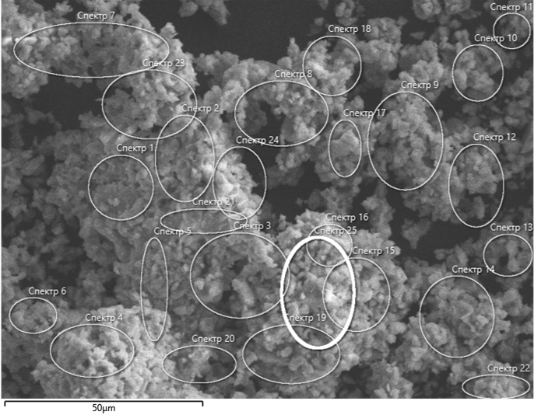

Fig. S1. Image of the areas for determining the composition of the LaMgAl11O19 sample

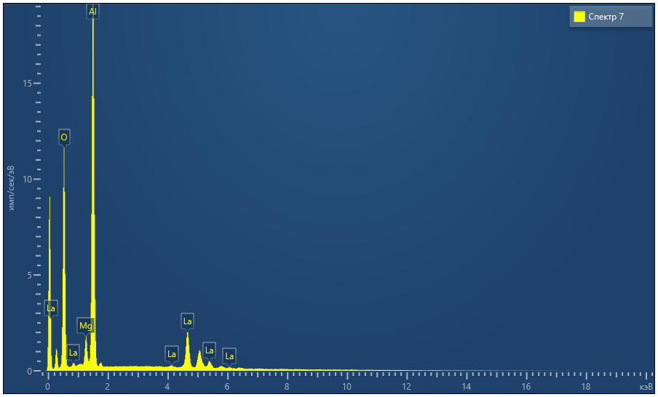

Fig. S2. EDX spectrum of LaMgAl11O19 sample

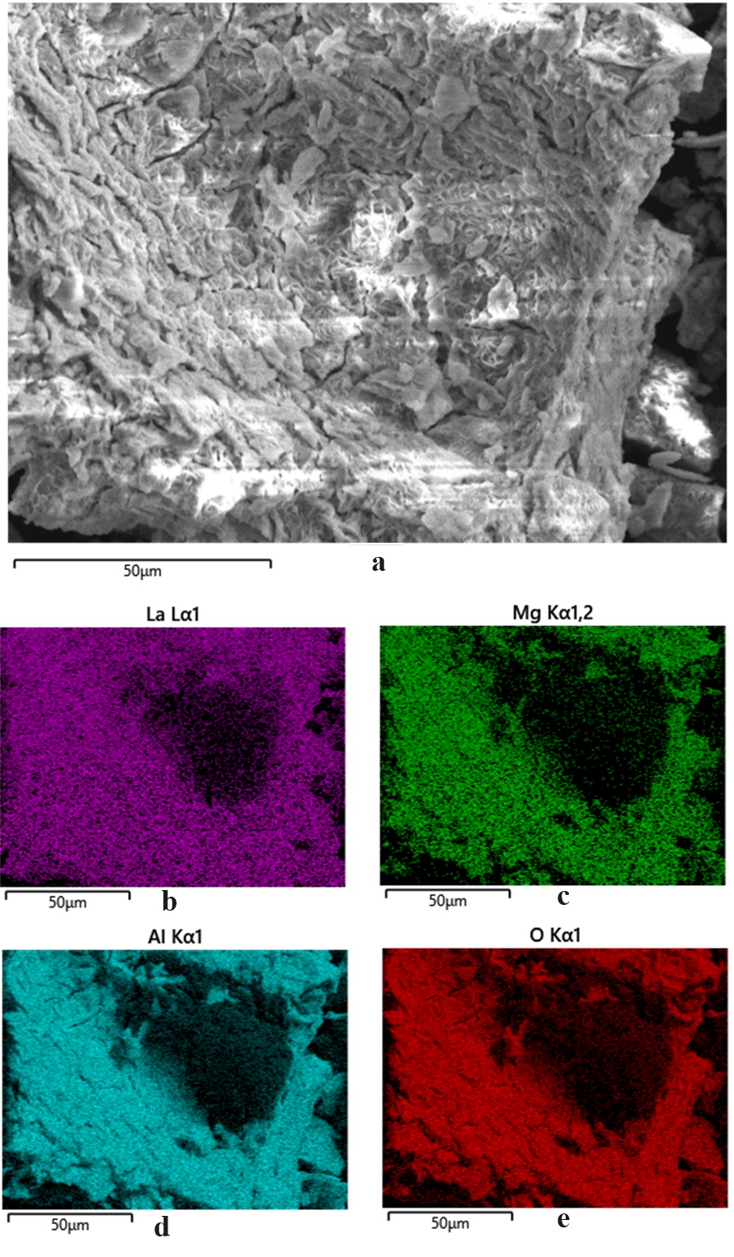

Fig. S3a-e. Mapping the distribution of elements on the surface of the LaMgAl11O19 sample.

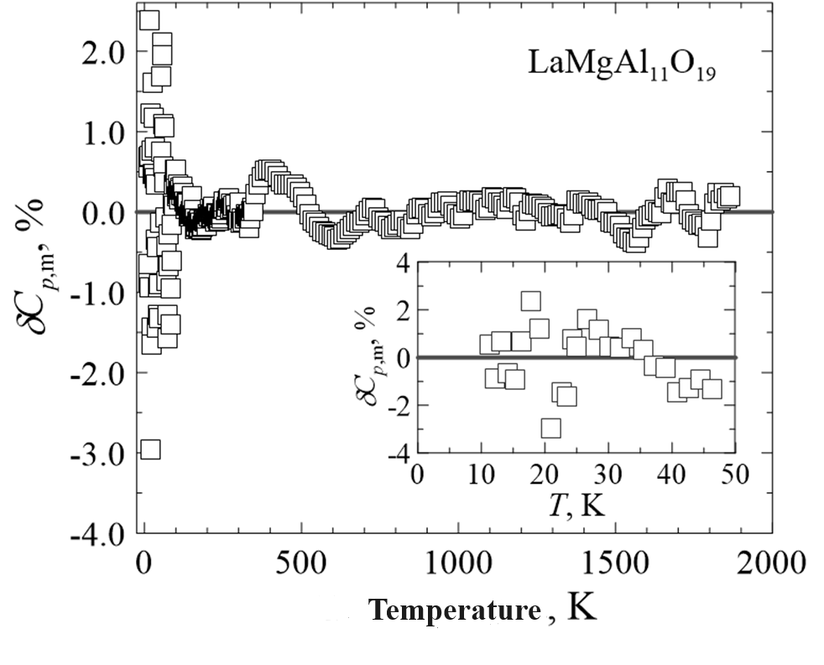

Fig. S4. Relative deviations (δ*Cp*,m, %) of the experimental values of the heat capacity of LaMgAl11O19 from the smoothing curve.

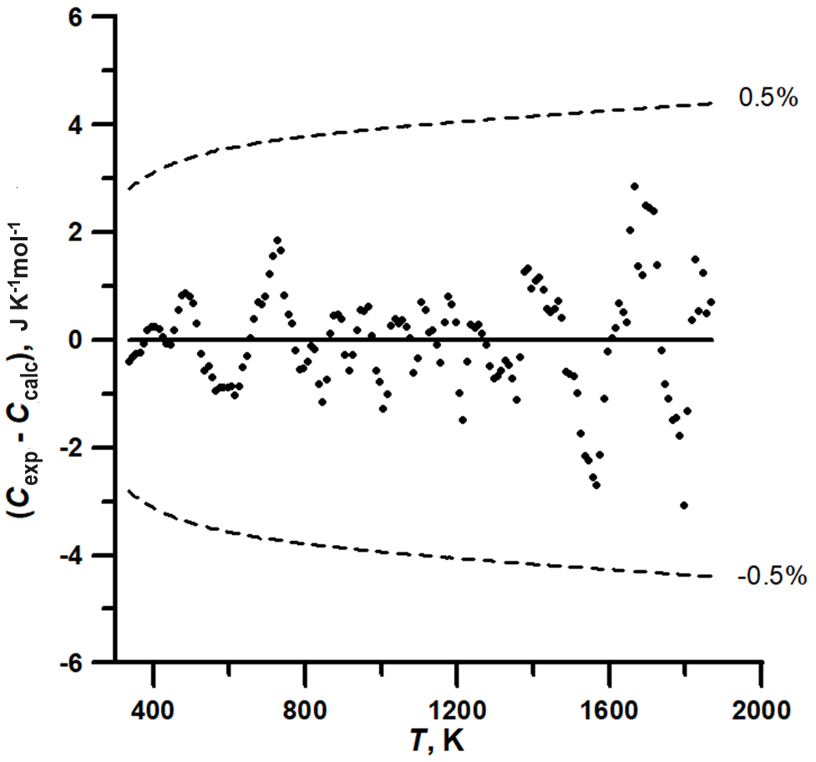

Fig. S5. Scattering of experimental values of the heat capacity of LaMgAl11O19 on the smoothed dependence calculated using equation (3).

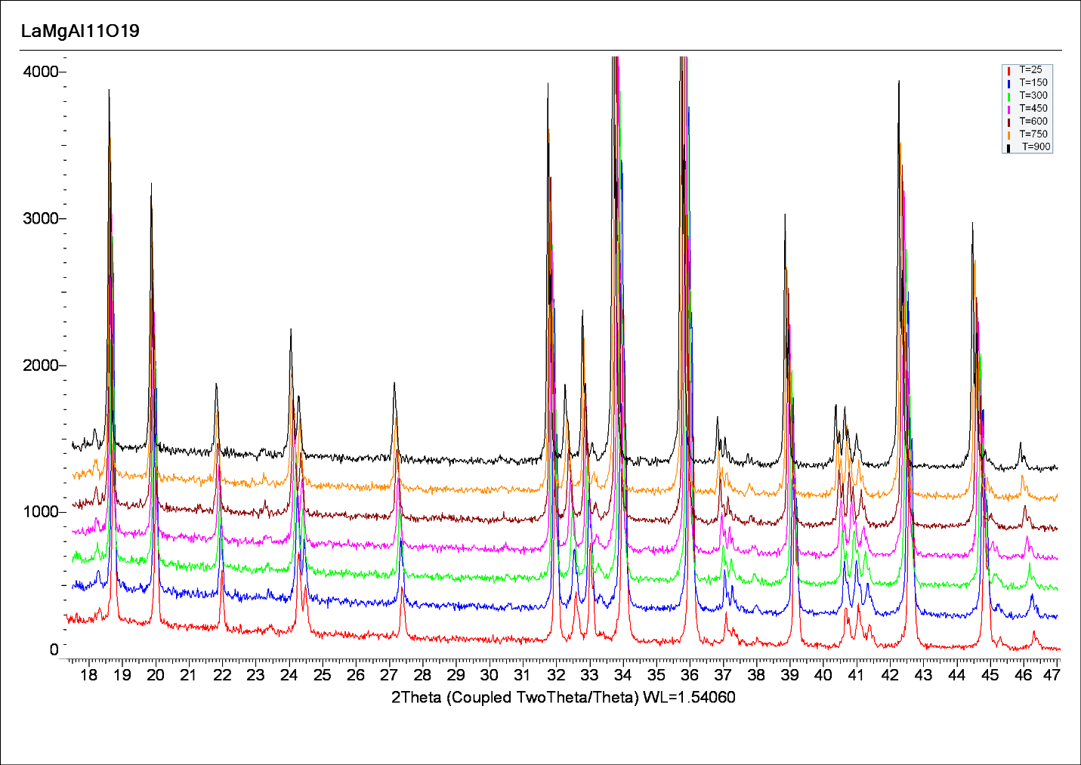

Fig. S6. X-ray diffraction patterns of the LaMgAl11O19 sample obtained at temperatures of 298 K, 423 K, 573 K, 723 K, 873 K and 1173 K.

Tables

Table S1. Heat capacity of LaMgAl11O19 in J K-1mol-1 according to relaxation calorimetry (MW = 763.998 g mol-1).

|  |  |  |  |  |  |
| --- | --- | --- | --- | --- | --- |
| *T*, K | *C*p | *T*, K | *C*p | *T*, K | *C*p |
| 7.28 | 0.1212 | 10.43 | 0.3560 | 16.35 | 1.373 |
| 7.29 | 0.1215 | 10.44 | 0.3574 | 16.36 | 1.376 |
| 7.29 | 0.1218 | 10.46 | 0.3594 | 16.49 | 1.409 |
| 7.73 | 0.1450 | 11.25 | 0.4470 | 17.66 | 1.729 |
| 7.73 | 0.1453 | 11.27 | 0.4496 | 17.82 | 1.776 |
| 7.74 | 0.1455 | 11.30 | 0.4528 | 17.99 | 1.827 |
| 7.84 | 0.1514 | 12.14 | 0.5614 | 19.07 | 2.177 |
| 7.84 | 0.1516 | 12.16 | 0.5643 | 19.21 | 2.227 |
| 7.85 | 0.1521 | 12.19 | 0.5685 | 19.42 | 2.301 |
| 8.34 | 0.1821 | 13.20 | 0.7228 | 20.66 | 2.768 |
| 8.34 | 0.1824 | 13.26 | 0.7318 | 20.94 | 2.884 |
| 8.35 | 0.1826 | 13.33 | 0.7437 | 20.96 | 2.892 |
| 8.97 | 0.2265 | 14.13 | 0.8867 | 22.43 | 3.542 |
| 8.99 | 0.2285 | 14.23 | 0.9041 | 22.59 | 3.622 |
| 9.00 | 0.2290 | 14.30 | 0.9191 | 22.59 | 3.623 |
| 9.67 | 0.2842 | 15.22 | 1.108 | 24.24 | 4.475 |
| 9.68 | 0.2853 | 15.29 | 1.123 | 24.36 | 4.541 |
| 9.70 | 0.2863 | 15.39 | 1.144 | 24.38 | 4.551 |

Table S2. Heat capacity of LaMgAl11O19 in J K-1mol-1 according to adiabatic calorimetry (MW = 763.998 g mol-1).

|  |  |  |  |  |  |
| --- | --- | --- | --- | --- | --- |
| *T*, K | *C*p | *T*, K | *C*p | *T*, K | *C*p |
| 23.40 | 3.999 | 77.31 | 69.35 | 187.63 | 326.2 |
| 23.99 | 4.392 | 78.56 | 69.94 | 189.57 | 330.4 |
| 24.97 | 5.013 | 78.56 | 71.40 | 191.50 | 334.6 |
| 25.55 | 5.412 | 79.19 | 72.70 | 193.44 | 338.8 |
| 26.69 | 6.194 | 80.56 | 73.75 | 195.37 | 343.0 |
| 27.28 | 6.593 | 81.13 | 76.49 | 197.31 | 346.9 |
| 28.40 | 7.378 | 82.49 | 77.76 | 199.24 | 351.4 |
| 28.99 | 7.774 | 84.42 | 81.80 | 201.14 | 355.5 |
| 30.13 | 8.635 | 86.36 | 85.87 | 203.07 | 359.6 |
| 30.72 | 9.092 | 88.30 | 90.14 | 204.99 | 363.5 |
| 31.87 | 10.04 | 90.24 | 94.37 | 206.91 | 367.6 |
| 32.47 | 10.59 | 92.18 | 98.40 | 208.84 | 371.7 |
| 33.63 | 11.59 | 94.13 | 102.8 | 210.76 | 375.4 |
| 34.24 | 12.10 | 96.07 | 107.2 | 212.68 | 379.1 |
| 35.40 | 13.13 | 98.02 | 111.5 | 214.60 | 382.9 |
| 36.01 | 13.57 | 99.97 | 115.7 | 216.52 | 387.1 |
| 37.19 | 14.72 | 101.91 | 120.4 | 218.44 | 390.5 |
| 37.80 | 15.32 | 103.87 | 124.4 | 220.35 | 394.6 |
| 38.98 | 16.48 | 105.82 | 129.0 | 222.27 | 397.8 |
| 39.60 | 17.11 | 107.77 | 133.8 | 224.18 | 401.2 |
| 40.79 | 18.15 | 109.72 | 138.3 | 226.09 | 405.1 |
| 41.41 | 18.90 | 111.67 | 142.8 | 228.00 | 408.8 |
| 42.61 | 20.09 | 113.62 | 147.7 | 229.92 | 412.2 |
| 43.23 | 20.94 | 115.57 | 152.5 | 231.82 | 415.6 |
| 44.44 | 22.17 | 117.52 | 157.1 | 233.73 | 419.3 |
| 45.07 | 22.86 | 119.48 | 162.0 | 235.64 | 422.4 |
| 46.28 | 24.15 | 121.43 | 167.0 | 237.54 | 425.8 |
| 46.91 | 24.95 | 123.39 | 171.6 | 239.44 | 429.3 |
| 48.13 | 26.41 | 125.34 | 176.6 | 241.34 | 432.8 |
| 48.77 | 27.31 | 127.29 | 181.3 | 243.24 | 436.0 |
| 49.99 | 28.85 | 129.25 | 186.0 | 245.14 | 439.1 |
| 50.63 | 29.89 | 131.20 | 190.9 | 247.03 | 442.5 |
| 51.85 | 31.43 | 133.16 | 195.9 | 248.93 | 446.1 |
| 52.50 | 32.48 | 135.11 | 200.8 | 250.82 | 449.3 |
| 53.73 | 34.16 | 137.07 | 205.7 | 253.68 | 454.3 |
| 54.38 | 35.09 | 139.02 | 210.6 | 257.56 | 460.1 |
| 55.62 | 36.81 | 140.98 | 215.1 | 261.41 | 466.4 |
| 56.28 | 37.76 | 142.93 | 220.0 | 265.26 | 472.8 |
| 57.52 | 39.35 | 144.88 | 224.9 | 269.09 | 478.8 |
| 58.16 | 39.93 | 146.83 | 229.9 | 272.93 | 483.9 |
| 59.41 | 41.63 | 148.79 | 234.7 | 276.75 | 489.8 |
| 60.04 | 42.34 | 150.74 | 239.5 | 280.56 | 495.0 |
| 61.30 | 44.08 | 152.67 | 244.7 | 284.38 | 500.5 |
| 61.92 | 45.19 | 154.61 | 249.0 | 288.20 | 505.8 |
| 63.19 | 47.04 | 156.56 | 253.7 | 292.00 | 510.3 |
| 63.80 | 47.63 | 158.51 | 258.6 | 295.79 | 515.1 |
| 65.07 | 49.54 | 160.45 | 263.1 | 299.58 | 519.9 |
| 65.69 | 50.39 | 162.40 | 267.4 | 303.26 | 525.7 |
| 66.96 | 52.17 | 164.34 | 272.1 | 307.02 | 529.1 |
| 67.58 | 53.17 | 166.29 | 276.8 | 310.77 | 533.9 |
| 68.85 | 54.93 | 168.23 | 281.6 | 314.52 | 538.1 |
| 69.47 | 55.72 | 170.17 | 286.1 | 318.26 | 542.7 |
| 70.75 | 57.70 | 172.12 | 290.5 | 322.00 | 547.3 |
| 71.52 | 58.30 | 174.06 | 295.0 | 325.73 | 551.4 |
| 72.80 | 60.621 | 176.00 | 299.8 | 329.45 | 555.5 |
| 73.42 | 61.471 | 177.94 | 304.2 | 333.16 | 559.6 |
| 74.71 | 63.98 | 179.88 | 308.3 | 336.87 | 563.2 |
| 75.34 | 65.06 | 181.82 | 312.77 | 340.57 | 567.6 |
| 76.63 | 67.70 | 183.76 | 317.24 | 344.26 | 571.5 |
| 77.27 | 68.89 | 185.70 | 321.6 | 347.93 | 575.0 |

Table S3. Heat capacity of LaMgAl11O19 in J K-1mol-1 according to differential scanning calorimetry (MW = 763.998 g mol-1).

|  |  |  |  |  |  |
| --- | --- | --- | --- | --- | --- |
| *T*, K | *C*p | *T*, K | *C*p | *T*, K | *C*p |
| 315 | 539.2 | 835 | 761.8 | 1355 | 826.6 |
| 325 | 550.6 | 845 | 763.1 | 1365 | 828.5 |
| 335 | 560.6 | 855 | 765.1 | 1375 | 831.1 |
| 345 | 572.3 | 865 | 767.5 | 1385 | 832.2 |
| 355 | 583.0 | 875 | 769.3 | 1395 | 832.9 |
| 365 | 592.9 | 885 | 770.9 | 1405 | 834.1 |
| 375 | 602.3 | 895 | 772.3 | 1415 | 835.2 |
| 385 | 611.1 | 905 | 773.1 | 1425 | 836.0 |
| 395 | 619.1 | 915 | 774.2 | 1435 | 836.7 |
| 405 | 626.6 | 925 | 776.0 | 1445 | 837.7 |
| 415 | 633.5 | 935 | 777.8 | 1455 | 838.8 |
| 425 | 639.9 | 945 | 779.6 | 1465 | 839.9 |
| 435 | 646.0 | 955 | 781.0 | 1475 | 840.7 |
| 445 | 651.8 | 965 | 782.4 | 1485 | 840.7 |
| 455 | 657.6 | 975 | 783.2 | 1495 | 841.7 |
| 465 | 663.2 | 985 | 783.9 | 1505 | 842.6 |
| 475 | 668.4 | 995 | 785.1 | 1515 | 843.3 |
| 485 | 673.1 | 1005 | 785.9 | 1525 | 843.6 |
| 495 | 677.5 | 1015 | 787.4 | 1535 | 844.2 |
| 505 | 681.6 | 1025 | 790.0 | 1545 | 845.1 |
| 515 | 685.3 | 1035 | 791.4 | 1555 | 845.8 |
| 525 | 688.6 | 1045 | 792.6 | 1565 | 846.7 |
| 535 | 692.0 | 1055 | 793.9 | 1575 | 848.2 |
| 545 | 695.7 | 1065 | 795.0 | 1585 | 850.3 |
| 555 | 698.9 | 1075 | 796.0 | 1595 | 852.1 |
| 565 | 701.9 | 1085 | 796.6 | 1605 | 853.4 |
| 575 | 705.2 | 1095 | 798.1 | 1615 | 854.6 |
| 585 | 708.2 | 1105 | 800.4 | 1625 | 856.0 |
| 595 | 711.1 | 1115 | 801.4 | 1635 | 856.8 |
| 605 | 714.0 | 1125 | 802.2 | 1645 | 857.6 |
| 615 | 716.6 | 1135 | 803.4 | 1655 | 860.3 |
| 625 | 719.4 | 1145 | 804.3 | 1665 | 862.1 |
| 635 | 722.3 | 1155 | 805.2 | 1675 | 861.6 |
| 645 | 725.0 | 1165 | 807.1 | 1685 | 862.5 |
| 655 | 727.8 | 1175 | 808.7 | 1695 | 864.7 |
| 665 | 730.5 | 1185 | 809.7 | 1705 | 865.7 |
| 675 | 733.1 | 1195 | 810.5 | 1715 | 866.6 |
| 685 | 735.3 | 1205 | 810.3 | 1725 | 866.6 |
| 695 | 737.6 | 1215 | 811.0 | 1735 | 865.9 |
| 705 | 740.1 | 1225 | 813.2 | 1745 | 866.3 |
| 715 | 742.5 | 1235 | 815.0 | 1755 | 867.0 |
| 725 | 744.8 | 1245 | 816.0 | 1765 | 867.6 |
| 735 | 746.6 | 1255 | 817.2 | 1775 | 868.6 |
| 745 | 747.7 | 1265 | 818.1 | 1785 | 869.2 |
| 755 | 749.3 | 1275 | 819.0 | 1795 | 868.9 |
| 765 | 750.9 | 1285 | 819.7 | 1805 | 871.6 |
| 775 | 752.2 | 1295 | 820.6 | 1815 | 874.3 |
| 785 | 753.7 | 1305 | 821.7 | 1825 | 876.3 |
| 795 | 755.4 | 1315 | 822.9 | 1835 | 876.3 |
| 805 | 757.3 | 1325 | 824.2 | 1845 | 878.0 |
| 815 | 759.2 | 1335 | 825.2 | 1855 | 878.2 |
| 825 | 760.8 | 1345 | 826.0 | 1865 | 879.4 |

Table S4. Coefficients of equations (1) and (2) used to calculate smoothed heat capacity values of LaMgAl11O19 in the range 0–1865 K.

|  |  |  |  |  |
| --- | --- | --- | --- | --- |
| Range |  | Coefficient |  | Coefficient value |
| Equation (1) | | | | |
| 0–13.5 K |  | *a* |  | 2.2050×10-4 |
|  | *b* |  | 1.0537×10-2 |
| Equation (2) | | | | |
| 13.5–1865 K |  | *α1* |  | 10.800480855871 |
|  | *α2* |  | 7.9889998412351 |
|  | *α3* |  | 16.899449664336 |
|  | *α4* |  | 3.6040885263874 |
|  | *α5* |  | 1.1879763747547 |
|  | *α6* |  | 0.05208283384027 |
|  | *θ1* |  | 1085.0641028994 |
|  | *θ2* |  | 6589.8874466002 |
|  | *θ3* |  | 594.89185221663 |
|  | *θ4* |  | 278.36914175716 |
|  | *θ5* |  | 135.95875121624 |
|  | *θ6* |  | 44.725397881712 |

Table S5. Unit cell parameters of LaMgAl11O19 according to high-temperature X-ray diffraction data.

|  |  |  |  |
| --- | --- | --- | --- |
| *T*, K | *a*, Å | *c*, Å | *V*, Å3 |
| 298 | 5.5932(2) | 21.970(1) | 595.24(6) |
| 423 | 5.5978(7) | 21.997(3) | 596.9(2) |
| 573 | 5.6036(7) | 22.030(3) | 599.1(2) |
| 723 | 5.6102(7) | 22.066(3) | 601.5(2) |
| 873 | 5.6153(7) | 22.098(3) | 603.4(2) |
| 1023 | 5.6235(7) | 22.139(3) | 606.3(2) |
| 1173 | 5.6311(6) | 22.178(3) | 609.0(2) |