*JOURNAL OF EXPERIMENTAL AND THEORETICAL PHYSICS, 2024, Vol. 165, No. 5, рр. 751–760*

**STATISTICAL, NONLINEAR, AND SOFT MATTER PHYSICS**

**ON THE IMPACT OF HIGH-ENERGY HELIUM PLASMA ION FLOW ON TUNGSTEN NANOSTRUCTURE**

**© 2024 V. V. Kulagin a,b,*, M. M. Tsventukh a,\*\***

*a Lebedev Physical Institute of the Russian Academy of Sciences, 119991, Moscow, Russia*

*b National Research Nuclear University MEPhI, 115409, Moscow, Russia*

*\* е-mail:* [*v.kulagin@lebedev.ru*](mailto:v.kulagin@lebedev.ru)

*\*\* е-mail:* [*mmtsv@lebedev.ru*](mailto:mmtsv@lebedev.ru) *,* [*elley@list.ru*](mailto:elley@list.ru)

Received November 21, 2023

Revised January 17, 2024

Accepted January 18, 2024

**Abstract.** The processes of plasma formation from helium bubbles-containing tungsten nanofibers when exposed to energy and particle flux from helium plasma under conditions of near-wall potential increased to hundreds of volts, when spontaneous initiation of explosive electron emission bursts is observed, have been considered. It is shown that the development of initiation models under external influence of energy and particle flux requires consideration of nanofibers heterophase structure. Using molecular dynamics method, atomistic modeling of interaction between an incident high-energy helium atom (100-500 eV) with an ensemble of helium atoms in a nanoscale bubble with solid-state of nanofibers heterophase structure 1029 m–3, retained in the near-surface tungsten layer, was performed. The energy relaxation time in the heterophase system of a nanobubble in tungsten was obtained, amounting to several picoseconds. It is shown that at incident particle energies of hundreds of electronvolts, overheating of near-surface nanobubbles is possible, leading to their explosion within times of about 10 ps. Such energy is comparable to the total energy of nanobubble particles, and at such near-wall potential, spontaneous initiations of explosive electron emission bursts are observed.

**DOI:** 10.31857/S004445102405e134

1. INTRODUCTION

Currently, tungsten is considered as one of the main materials for plasma-facing components of future thermonuclear facilities, such as ITER. Tungsten is characterized by high melting temperature, low sputtering ratio, low hydrogen isotope capture, but is subject to structural changes when the surface is irradiated with helium plasma ions. Helium irradiation of tungsten leads to the development of surface morphology with the formation of nanostructures known as tungsten nanofuzz [1].

The characteristic conditions for the formation of tungsten fuzz are as follows: surface temperature,

helium bubbles [3]. The physical properties of tungsten nanofuzz, as a plasma-facing material, differ significantly from those of pure tungsten. One of the negative effects associated with the formation of tungsten nanofuzz is the increased probability of unipolar arc ignition, which leads to increased erosion of the plasma-facing surface [4, 5, 6].

Currently, the growth mechanisms and properties of tungsten fuzz have been studied in detail for the case of tungsten surface irradiation with low-energy helium ions of 20– 00 eV [7, 8, 9, 10, 11]. At higher energies (hundreds of electron volts), fiber growth is replaced by sputtering, and "breakdowns" –

*T* = 900–2000 К, helium ion energy *E*0 > 20 eV,

bursts of explosive electron emission current – are

irradiation dose  > 1020

сm-2

[2]. The typical

spontaneously initiated [12, 13, 14].

transverse size of individual nanostructures is usually about 0 nm, and their height can reach several micrometers depending on the f lux and dose of irradiation. It is important to note that these nanostructures also contain trapped helium both in dissolved state and in the form of formed

This work investigates the energy release process of external plasma ion flux incident on the nanostructure, under conditions corresponding to the formation of metallic plasma from nanofibers. Section 2 provides estimates of plasma properties resulting from explosive electron emission bursts, following from vacuum

751

discharge theory and nanostructure properties.

where *M* W and *M*He — are masses of tungsten

Section 3 discusses energy transfer in atomic collisions. Section 4 describes the numerical simulation of energy relaxation processes of incident helium atom in a heterophase system with helium nanobubble in tungsten using molecular dynamics method. Section 5 contains discussion of the obtained results.

and helium atoms, *E*0 — is the energy of helium ions incident on the surface, *Ecoh* — is the binding energy of tungsten atoms (under normal conditions

*Ecoh* = 9 eV, but due to nanostructure may be lower [17, 21]), *T*W — is the temperature of tungsten layer atoms corresponding to the equilibrium of heating

and cooling flows *T*W  1 eV [5]. Further ionization

1. BREAKDOWN INITIATION UNDER PLASMA EXPOSURE

The operation of unipolar arc discharges

occurs when exposed to external plasma[5].

For plasma pulse conditions in the form of ELM (Edge Localized Mode) [18], having particle energy *E*0

represents a pulse-periodic formation of plasma

of about 1 keV and plasma density *npl* of about

clusters from the surface material due to bursts of explosive electron emission [15, 16]. The equivalent sputtering ratio (ratio of tungsten density leaving the wall to plasma density) can reach  10 [17], which is orders of magnitude higher than physical sputtering of tungsten by low-energy light ions [18, 19].

For a "clean" surface, the threshold of external energy flux from plasma *q* was obtained at the level of 200 МВ / t cm2, which is sufficient to compensate for intensive surface cooling by electron emission and provides explosive Joule overheating of surface areas – explosive emission [20]. In this case, with low external plasma density and high energy of its particles, this large energy flux *q* from the surface material can create dense plasma, ensuring the flow of highdensity emission current *j*, sufficient for explosion. The limiting value is approximately

f ö1/ 2

1014 сm-3, the density *n*1 сwill be more than 1018 сm-3, which corresponds to the lower boundary of plasma density sufficient to initiate explosive emission bursts,

according to works [22, 23]. However, spontaneous initiation is also observed – without a trigger in the form of energy flux.

# Spontaneous initiation

As early as in the first experimental study of plasma interaction with such nanostructured tungsten surface in a large thermonuclear facility – the LHD (Large Helical Device) stellarator [12] – arc discharges were initiated in stationary plasma with density at the level of 1012 сm-3 and energy of ions falling on the surface 00–200 eV in the divertor region. The energy flux *q* and corresponding density *n*1 (expression (2)) turn out to be several orders of

*j*  *j*

= *en*

ç *Te* ÷ ,

(1)

magnitude lower than in the case of pulse plasma

*M pl pl* èç2*me* ø**÷**

where *n* and *T* — are plasma density and electron

impact during ELM (which do not occur in plasma

confined in stellarator magnetic configuration),

namely about 1015 сm-3.

*pl e*

temperature in it.

Similar plasma parameters (density at the

The presence of developed surface nanostructure

level of

1012

сm-3) were also in subsequent

can significantly facilitate the formation process of such primary plasma, as it is obvious that due to nanostructure, the number of bonds between surface material atoms decreases. In work [5], an "isolated layer" model was proposed to evaluate parameters of such plasma. The concentration of atoms, according to this model, can be approximately estimated from the equality of incoming plasma energy flux and energy f lux carried away by tungsten atoms evaporation, namely:

experiments in the linear simulator NAGDIS-II [13, 14], where spontaneous initiation was studied separately. The main influence on initiation was caused by the increase in near-wall potential from approximately 300 V to 400-500 V [13]. Obviously, the corresponding increase in energy f lux and corresponding density *n*1 by only .5–2 times (see (2)) cannot explicitly explain the initiation of explosive emission bursts.

Note, moreover, that the considered "energy"

fç *M*

÷ö 1/ 2

*E* 3/ 2

model [5] does not take into account, firstly, the

*n*1 = *npl* ç W ÷**÷**

è *M*He ø

0 1/ 2 ,

*EcohT*W

(2)

large amount of gas in the fibers, and secondly, the reduction in the average binding energy of tungsten

atoms in the nanostructure, as the corresponding quantitative studies were conducted later.

# Helium Content

The lowest measured value á*n*ñ / *n*W was about 5% [28], which gives for the average binding energy á*Ecoh* ñ» 0.5 eV. Taking this value into account in equation (2) will increase the estimated density

value *n*1 by *Ecoh* / á*Ecoh* ñ = 18 times, to the level

As a result of direct experimental measurements, the amount of helium contained in the nanostructure of fibers was determined [24]. The particle ratio was He/W 3 ± 4%. Given that the density of tungsten under normal conditions is *n*W » 6 × 1022 сm-3,

of 1016 сm-3.

These features are associated with the "fine structure" of the considered heterophase system of nanofibers, whose properties need to be correctly accounted for in the plasma formation problem.

the average helium concentration in nanofibers

will be approximately á*n*Heñ  1022 сm-3. The release of such amount of gas during large-scale destruction of fibers can significantly affect plasma

parameters. Although the ionization potential of helium (*I* = 25 eV) is significantly higher than

+1

He

that of tungsten (*I* +1 = 7.98 eV), which leads to

W

preferential formation of metallic plasma rather than gas plasma, explosions of nanometer-sized bubbles with approximately solid-state gas density in them, *n*He at the level of 1023 сm-3 [24], will lead to

filling the volume of nanofiber structure with high-

concentration gas.

For cubic expansion *nr*3 = const and initial bubble size of 1 nm, we obtain a decrease in gas concentration with distance:

1. ENERGY TRANSFER IN COLLISIONS

# Helium-Tungsten Collisions

Based on the ratio of atomic masses of tungsten and helium

*M* W / *M*He » 46,

it can be seen that in each collision only a small portion of energy is transferred from helium to tungsten atoms, and complete transfer will occur over a number of collisions on the order of *M* W / *M*He.

At energy *E*0 = 50 eV, exceeding the threshold value for initiating fiber growth [2], the amount of energy transferred to tungsten atoms is

*n*He(*r*) = 100 / *r*3,

*E*0 *M*He / *M* W

 1 eV,

which gives high concentration 1020

сm-3

and

which is sufficient for heating the fibers and may

1017

сm-3

at distances of 10 nm and 100 nm,

be significant for their growth. When helium ion

corresponding to the distance between adjacent nanofibers.

energy increases to 500 eV, the energy transferred to tungsten atoms can reach

# 2.3. Binding Energy

*E*0 *M*He / *M* W

 10 eV,

Based on the model linking the average charge of explosive emission plasma ions in vacuum arc discharge and the binding energy of cathode metal atoms [25, 26], as well as experimental results on plasma ion charge in vacuum arc burning on tungsten nanofiber layers [27], the average binding energy for such nanostructure was estimated [17]:

which is comparable to the binding energy of tungsten under normal conditions (*Ecoh* = 9 eV) and may be sufficient for significant sputtering of

nanofibers. As noted in [13], sputtering may be important for spontaneous initiation when the potential increases.

The total trajectory length *L* will be

á*Ecoh* ñ = 10 eVá*n*ñ / *n*W ,

(3)

*L*  *aM* W / *M*He » 14 nm

where á*n*ñ — is the average concentration of atoms in fibers, ranging from several hundredths to tenths of the tungsten concentration under normal conditions (*n*W).

(where *a* = 3.165 is the crystal lattice period of tungsten), which in order of magnitude coincides with the transverse size of nanofibers – tens of nanometers [1].

To estimate the penetration depth, it is necessary to consider large-angle scattering during collision of particles with greatly differing masses. However, more important is the presence of large amounts of

*Ei dE* ¢ *N* (*Ei* ,*E f* ) = ò á*E* ¢ñ,

*E f*

(4b)

previously implanted helium in the fibers. *E* 

# Helium-helium collisions

At average concentration á*n*Heñ  1022

сm-3

á* E*ñ =

2 ò (1 - cos **) ** (**,**)*d*,

0

2 sin * d*(**,**)

(4c)

He-He collisions will be quite frequent, but even more importantly, in such collisions, due to equal

** (**,**) =

**(**)

*d* ,

(4d)

masses, transfer of a large part or all energy can occur. During the growth of nanofibers, helium atoms accumulate in tungsten and combine into nanobubbles with gas concentration of solid-state

where *N* — is the average number of collisions needed to reduce the energy of a fast atom from initial value *Ei* to final value *E f* , *v*(*E*) — fast atom

velocity, á* E* ñ — is the average fraction of energy

order *n*  1023 cm-3 . An incident helium atom in

transferred during elastic collision between helium

such a bubble can lose all energy in a single collision, with collisions occurring at a frequency

*nv*  1014 s-1,

atoms, *θ* — is the scattering angle in the center of mass system, *ε* is the particle collision energy in the center of mass system, *ρ*(*ε,θ*) — is the normalized probability density distribution of scattering angles,

where **  107 cm/c — is the velocity of the incident

*σ*(*ε*) and *d*(**,**) / *d* — are total and differential

helium atom, ** » 10-16 cm2 — is the collision cross- section [29]. More detailed results can be obtained based on work [30]. Let's estimate the relaxation

time ( **He ) of an atom in an infinite volume filled

with atom s of helium at a temperature equal to 1000 K, according to equations [30]

scattering cross-sections respectively.

Using expressions for total and differential scattering cross-sections from [30], obtained by approximating quantum mechanical calculation results, and numerically integrating equations (4), we can estimate the thermalization time of a fast atom with energy *E* = 100–500 eV in gas with

*N* ¢

**  *dN*

He = ò ,

(4a)

temperature *T* = 1000 К and concentration *n* = *n*W.

0 *n* (*E*(*N* ¢) / 2)**(*E*(*N* ¢))

The obtained relaxation time of a fast helium atom is of the order of 10-100 fs (see Fig. 1).

However, the characteristic mean free path before collision

� = 1

� = 2

� = 3

� = 4

� = 5

� = 6

250

●  1 / *n*  1 nm

(5)

200

Relaxation time (fs)

150

100

50

0

100

200 300 400

Incident energy (eV)

500

is comparable to the characteristic sizes of nanobubbles [31]. This means that a heterophase system needs to be considered. Detailed results can be obtained based on atomistic modeling [32, 33, 34].

Note that the surface heating up to 900-2000 K, necessary for nanofiber growth, occurs due to the considered ion flux from plasma. The energy relaxation rate in such a heterophase system will determine whether "uniform" heating occurs or energy localizes in the bubble, which can lead to its "explosion".

**Fig. 1.** Dependencies of energy relaxation time of a fast helium atom in an infinite volume filled with helium at a temperature of 1000 K and different concentration values

We will perform numerical atomistic modeling using molecular dynamics method to study the interaction process between a helium atom with

elevated energy (hundreds of electronvolts) and a tungsten nanostructure containing a helium nanobubble with solid-state gas density.



Free space

Incident He-atom

He-bubble

Mobile W-atoms

Frozen W-atoms

1. MOLECULAR DYNAMICS MODELING

# Methodology

Molecular dynamics calculations were performed using the LAMMPS software package [35, 36]. The interaction between tungsten atoms was described by the EAM Finnis-Sinclair potential [37, 38] with modifications for close-range interactions from Ackland and Thetford [39] and ultra-close interactions from Juslin and Wirth [40]. The tungsten-helium interaction was defined by the Juslin and Wirth pair potential [40], while the helium-helium interaction was described by the Beck pair potential [41,42] with modification for small distances from Morishita et al. [43].

This set of interatomic interaction potentials

allows for sufficiently accurate reproduction of z

*ab initio* calculations [40] and is frequently used both

for analyzing the dynamics of dissolved helium in x

tungsten at fixed temperature [32, 33, 44, 45, 46], and for modeling cumulative irradiation of tungsten surface with helium atoms with initial energy in the range of 100–500 eV [47, 48, 49]. It is important to note that inelastic energy losses of fast particles during their deceleration in the material volume are not explicitly accounted for in molecular dynamics modeling. According to the TRIM software package [50], the fraction of inelastic losses during the deceleration of a helium atom with initial energy of 500 eV is » 60% in tungsten and » 14% in helium.

**Fig. 2.** Initial geometry used in modeling the interaction of a fast helium atom with a helium bubble. Gray spheres – mobile tungsten atoms, black spheres – "frozen" tungsten atoms, green spheres – helium bubble atoms, red sphere – incident helium atom. The red arrow shows the direction of the incident atom's initial velocity. Some mobile tungsten atoms are hidden for clarity

with radius with a center in a plane parallel to the surface were removed from the perfect tungsten lattice. The depth of the sphere's center of symmetry was selected so that the given configuration remained stable during thermalization at *T* = 1000 К.

Considering this, the energy relaxation times of helium bubbles estimated in this work represent the upper limit of possible values.

The geometry represented a model tungsten surface with dimensions 40 *a* ´40 *a* ´50 *a* and

Then, a specified number of helium atoms were randomly placed in the cut-out sphere. Helium bubbles with radii from *a* to 4*a* (from 3.183 Å to 2.732 Å) were considered with a bubble occupancy

value ( ** = *N*He / *NV* — ratio of the number of

orientation (100) at temperature *T* = 1000 K (Fig. 2),

helium atoms *N*He to the number of vacancies *NV* in

*a* = 3.183 Å. Periodic boundary conditions were set along the *x* and *y* axes, while free atomic movement was allowed along the *z* axis. The four bottom atomic layers were "frozen" (velocity equals zero) to prevent geometry migration. Above the tungsten atoms, an additional empty region with thickness 10 *a* was set to simulate a free surface.

The creation of the helium bubble was carried out in two stages. First, atoms lying in a sphere

the helium bubble) equal to 2, chosen based on the results of multiscale modeling of cumulative helium irradiation of the tungsten surface [32, 33]. The corresponding concentration *n* = 2** / *a*3 » 1023 cm-3 . Then, system thermalization was conducted for 500 ps using the Nose-Hoover thermostat [51, 52].

To simulate the interaction of a fast atom with a bubble, a test helium atom was placed on the surface of a sphere with radius (*r* + *a*) with initial energy *E*0

and velocity vector directed towards the sphere's center (Fig. 2). This approach excludes model cases of bombarding atoms reflecting from the surface and thermalization of fast atoms in tungsten that missed the bubble, which would be observed when modeling the irradiation of a tungsten surface area containing a helium bubble. The initial energy was fixed and ranged from 100 to 500 eV. To obtain more detailed results during the simulation, a variable time step from the range of 0.01– fs was used. The time step value was updated every 10 iterations and was selected so that no atom would move more than 0.05 Å during one iteration. The calculation was terminated when the total kinetic energy of the bubble decreased to 1.025 of the initial level. During the interaction modeling, the thermostat was turned off, and the total system energy was fixed.

Visualization of atomic configurations was performed using the free version of the OVITO software package [53]. All pseudo-random numbers used during the simulation were generated based on the "Mersenne Twister" algorithm [54], implemented in the Python "random" module. Additionally, the pressure of helium bubbles (*Pbubble* ) was evaluated

based on the virial relation

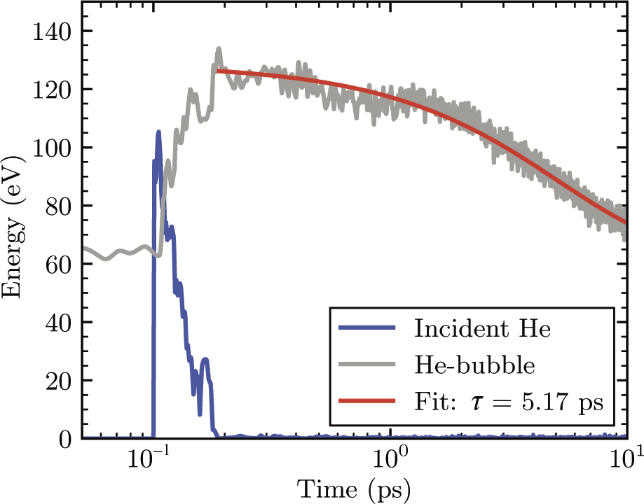

**Fig. 3.** Time dependencies of helium bubble energies (*r* = 3*a*, *NV* = 245, *N*He = 490) and incident helium atom (*E*0 = 100 eV). The fast helium atom is introduced into the system at 0.1 ps

Note that the thermalization of the fast atom in this helium bubble surrounded by tungsten atoms occurs within about 0.1 ps, which is 2.5 times longer than the corresponding value obtained based on expressions (4). It is important to note that the approximation analytical expressions for total and differential scattering cross-sections given in [30] have the highest error for helium-helium collisions.

* bubble* =

1 çf*m *2

3*V* **ç**è *i*

ç *i*

å

ö

+ 2 å**r***ij* × **F***ij* ÷,

**÷**

1 ÷

(6)

Nevertheless, the obtained times are close in magnitude, which confirms the efficiency of energy

*i j* ø

where *i* — is the ordinal number of the helium atom in the bubble, *j* — is the ordinal number of the neighboring atom from the *i*-th atom, *mi* — is

the mass of the *i*-th atom, *vi* — is the velocity of the

*i*-th atom, **F***ij* — is the force vector acting on the *i*-rd

atom from the *j*-th atom, **r***ij* — is the radius vector

transfer from the fast helium atom to the helium bubble atoms.

To estimate the characteristic energy relaxation time of helium bubbles, each time dependence of the total bubble energy was approximated by the expression

from the *j*-th atom to the *i*-st atom, *V* — is the volume of the helium bubble, which was determined

*E*(*t*) = *A* + *B* exp(-*t* / ** )

(7)

based on the Voronoi diagram method implemented in LAMMPS.

# Energy relaxation time

About 103 calculations were performed for each configuration( , *E*0), where the position of the incident helium atom and helium atoms in the bubble during preliminary thermalization was randomly set. An example of time evolution of the kinetic energy of the fast atom and total kinetic

(red line in Fig.3). Then for each series of simulations, the distribution density of the characteristic time *τ* was determined using the Parzen-Rosenblatt approximation method [55,56]. Fig. 4 shows the distribution densities of the characteristic relaxation time of the total helium bubble energy depending on its radius (a) and the initial energy of the incoming atom (b). It can be seen that the characteristic relaxation times after the fast atom entry *τ* are units of picoseconds, while complete energy relaxation is

energy of the helium bubble (*r* = 3*a*, *NV N*He = 490) is shown in Fig. 3.

= 245,

achieved in time of order 3*τ*, which agrees with the exponential dependence.

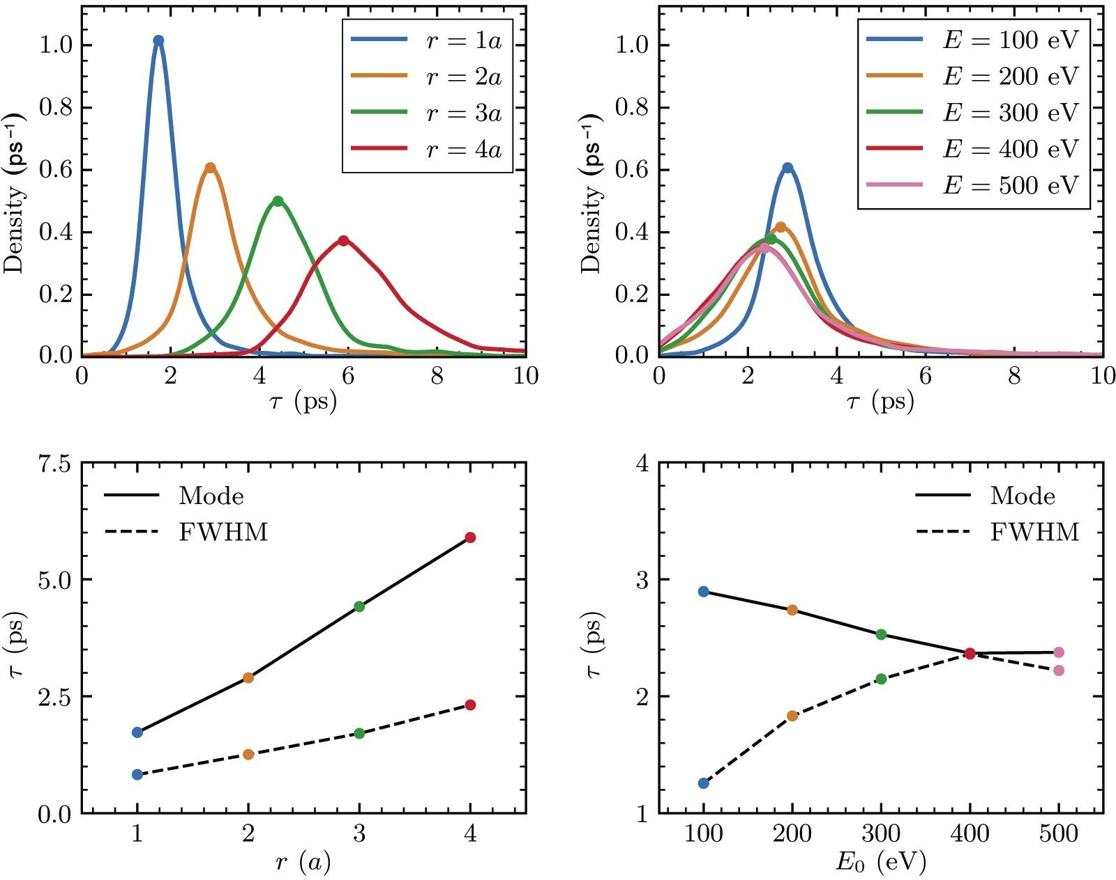

**Fig. 4.** Distribution density of the characteristic energy relaxation time of the helium bubble after the entry of a fast helium atom depending on the bubble radius (*a*) at *E*0 = 100 eV and depending on the initial energy of the incident atom (*b*) at *r* = 2*a*. *c*, *d* — corresponding dependencies of mode and FWHM-distributions

From the dependencies shown in Fig. 4, it can be seen that with increasing bubble size, the average relaxation time increases approximately linearly á**ñ:

1. DISCUSSION

Let's estimate the time for a new helium atom to enter the bubble *τimpl*. The characteristic ion flux

á** ñ [ps] = 0.23 + 1.40(*r* / *a*),

(8)

from the near-wall plasma  *pl* under experimental

conditions [12-14] is  *pl*  1019 сm -2× s-1 . The

as well as the full width at half maximum *δτ*: transverse size of the helium nanobubble - "collision

(9)

cross-section" — ** *bubble* = *r* 2  10-14 сm2. Then

** [ps] = 0.29 + 0.49(*r* / *a*).

for the characteristic time we obtain the value

It can also be seen that with increasing initial energy *E*0 the average relaxation time decreases linearly, while the distribution width increases.

Thus, the energy of the incident helium atom can indeed be effectively transferred to the ensemble of bubble atoms. Over picosecond timescales for nanometer-sized bubbles, relaxation and energy transfer from gas to tungsten atoms occurs.

**  ( ** )-1 = 10 s. (10)

Obviously, *τimpl* significantly exceeds the obtained energy relaxation times, which are units of picoseconds. Thus, the non-equilibrium state with increased energy in the nanobubble gas will be observed only for units of picoseconds after the impact of a fast particle

*impl pl bubble*

  

**Fig. 5.** Time dependencies of pressure (*Pbubble*) and total kinetic energy (*Ebubble*) of the helium bubble (*r* = 4*a*, *N*He = 1100, *NV* = 537) during its destruction caused by the implantation of a helium atom with increased energy (*E*0 = 250 eV)

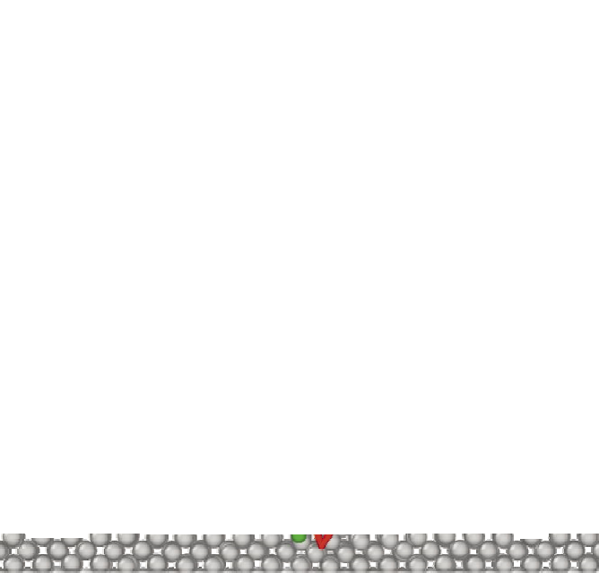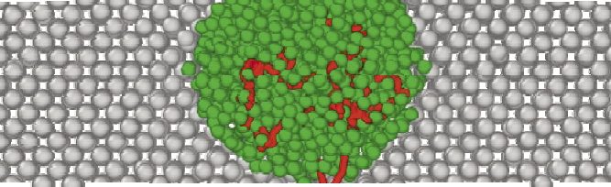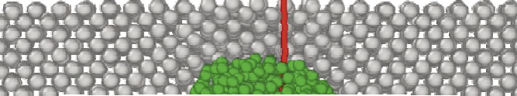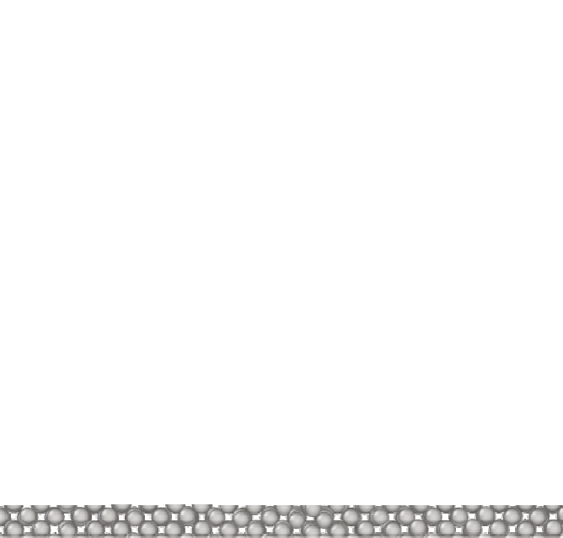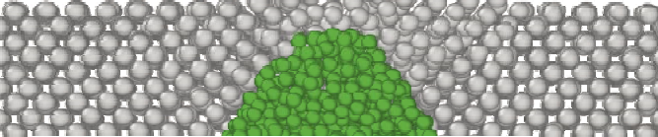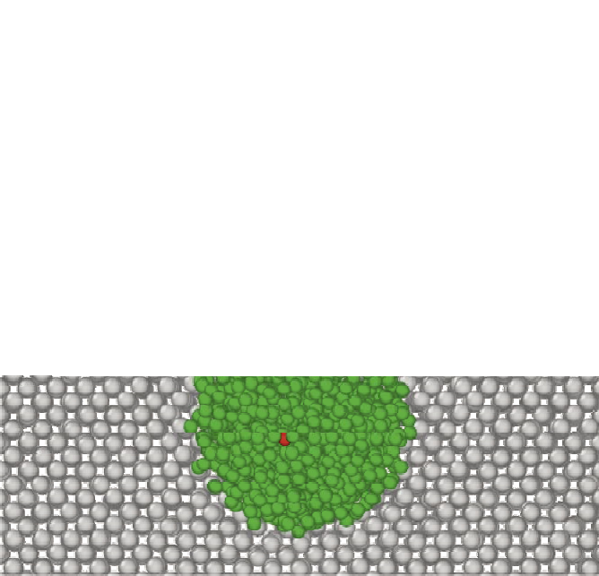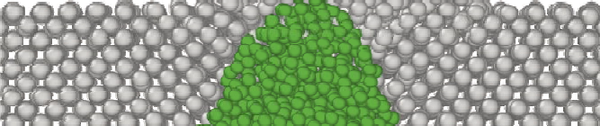

In a recent work [57], the processes of "explosive" destruction of near-surface helium nanobubbles under high gas pressure were studied. Based on molecular dynamics simulation results, equations of state for helium bubbles retained in tungsten were obtained, and critical parameters (bubble depth relative to the surface *h* and their population *φ*), at which their explosion occurs were determined. The equilibrium temperature distribution - "slow"

rate itself will be determined by the tungsten temperature and geometry and can be comparable for both cases.

In our calculations (see geometry in Fig. 2), we set a deep bubble location to obtain a stationary solution. Obviously, bubbles lying close to the surface will explode. Let's consider such an example case, shown in Fig. 5, where a fast helium atom with initial energy of 250 eV enters a helium bubble

explosions - was considered. In this case, bubble

(*r* = 4*a*, *N*He = 1100, *NV* = 537 , ** » 2 ), initially

destruction at a fixed temperature occurs due to reaching a critical number of atoms (concentration) of helium in the bubble. In our case, we can consider "fast" bubble explosions - when the additional energy transferred to the bubble from the incident particle does not relax, leading to a short-term increase in the kinetic pressure of the helium bubble (the first term in the right-hand side of equation (6)) and, consequently, its explosion. Specifically, let's consider "fast" explosions – over times less than

located at a depth of 6*a* at a temperature of 1000 K.

It is evident that, indeed, within picoseconds after a fast atom falls into a near-surface bubble, its explosive destruction occurs, releasing a large amount of trapped helium. Let us recall that the helium concentration in bubbles at the level of 1023 сm-3 is approximately 3.5 orders of magnitude higher than the gas concentration at atmospheric pressure (2.7 × 1019 сm-3) and 0 orders of magnitude

3**  10 ps (equation (8)). Note that the destruction



higher than the gas concentration corresponding to

the working pressure in experiments on nanofiber growth and spontaneous initiation [12, 13, 14].

When gas expands in the vacuum, the boundary velocity reaches [58]

4

*Ebubble*

 -1 *M*He*N*He

of near-wall potential, when spontaneous initiation of explosive electron emission bursts is observed. It is shown that the development of initiation models under external influence of energy and particle flux requires consideration of the heterophase structure

*umax* =

, (11)

of nanofibers.

Using molecular dynamics methods, atomistic

which for the parameters in Fig. 5 gives 6.2 × 105 cm/s (adiabatic index  = 5 / 3). The distance to neighboring nanofibers (tens of nanometers) will be covered in about 10 ps. Mechanical momentum transfer can be significant for the destruction of surface bubbles in neighboring nanofibers (see [17]).

It should also be noted that the total energy

modeling of the interaction of an incident helium atom of increased energy (hundreds of electron volts) with an ensemble of helium atoms in a nanoscale bubble with solid-state gas concentration, retained in the near-surface layer of tungsten, was performed. The energy relaxation time in the heterophase system of a nanobubble in tungsten was obtained, amounting to units of picoseconds.

of helium atoms in a nanoscale bubble

*Ebubble*,

It was also demonstrated that at the energy of

being in equilibrium with tungsten having a temperature in the range of 900–2000 К, is about 100 eV (see Fig. 3 and 5). Thus, the energy of incident helium particles *E*0 at the level of tens of electron volts, corresponding to nanofiber growth (*Egrowth* ),

is insufficient for significant bubble overheating:

incident particles at the level of hundreds of electron volts, overheating of near-surface nanobubbles is possible, which leads to their explosion within times of about 10 ps. Such energy is comparable to the total energy of nanobubble particles, and at such near-wall potential, spontaneous initiations of

*Egrowth* < *Ebubble* < *Esi* .

(12)

explosive electron emission bursts are observed.

The released energy *E*0 dissipates and provides heating of the entire nanostructure. Conversely, increasing the energy *E*0 to hundreds of electron volts(*E*0 = *Esi* ) is sufficient for a noticeable

increase in the energy of the particle ensemble in

the bubble for a picosecond duration – sufficient for "rapid" explosion of bubbles near the surface

ACKNOWLEDGMENTS

Molecular dynamics calculations were performed using the resources of the High-Performance Computing Center of National Research Nuclear University MEPhI.

(Fig. 5). This energy

*Esi*

corresponds to an

FUNDING

increase in the near-wall potential to hundreds of electron volts, *Esi* = *eUsi* — when breakdowns are spontaneously initiated.

Let us emphasize that for the release of a large amount of tungsten and formation of metallic plasma, a greater energy input is required, which can be provided by Joule heating during current flow, which was not considered in this work.

1. CONCLUSION

The processes of plasma formation from tungsten nanofibers containing helium bubbles under the influence of energy and particle flux from helium plasma have been considered. The conditions correspond to experiments with increased energy of incident particles – increased to hundreds of volts

This work was supported by the Russian Science Foundation (project No. 22-12-00274).

REFERENCES

1. S. Kajita, N. Yoshida, and N. Ohno, Nucl. Mater. Energy 25, 100828 (2020).
2. J. Wright, Tungsten 4, 184 (2022).
3. K. D. Hammond, Mater. Res. Express 4, 104002 (2017).
4. S. Kajita, S. Takamura, and N. Ohno, Nucl. Fusion 49, 032002 (2009).
5. S. A. Barengolts, G. A. Mesyats, and M. M. Tsventoukh, IEEE Trans. Plasma Sci. 39, 1900 (2011).
6. D. Hwangbo, S. Kawaguchi, S. Kajita, and N. Ohno, Nucl. Mater. Energy 12, 386 (2017).
7. S. Kajita, W. Sakaguchi, N. Ohno et al., Nucl. Fusion 49, 095005 (2009).
8. Y. Martynenko and M. Nagel', Plasma Phys. Rep. 38, 996 (2012).
9. M. Baldwin and R. Doerner, Nucl. Fusion 48, 035001 (2008).
10. S. Krasheninnikov, Phys. Scripta T 145, 014040 (2011).
11. S. Kajita, N. Yoshida, R. Yoshihara et al., J. Nucl. Mater. 418, 152 (2011).
12. M. Tokitani, S. Kajita, S. Masuzaki et al., Nucl. Fusion 51, 102001 (2011).
13. S. Kajita, Y. Noiri, and N. Ohno, Phys. Scripta 90, 095604 (2015).
14. R. Zhang, S. Kajita, D. Hwangbo et al., Nucl. Mater. Energy 31, 101178 (2022).

**15.** G. A. Mesyats, J. Nucl. Mater. 618, 128 (1984).

1. S. A. Barengolts, G.A. Mesyats, and M. M. Tsventoukh, Nucl. Fusion 50, 125004 (2010).
2. M. M. Tsventoukh, Phys. Plasmas 30, 092511 (2023).
3. A. Loarte, B. Lipschultz, A.S. Kukushkin et al., Nucl. Fusion 47, S203 (2007).
4. V. S. Mikhailov, P. Yu. Babenko, A. P. Shergin et al., J. Exp. Theor. Phys. 137, 413 (2023).
5. S. A. Barengolts, G. A. Mesyats, M. M. Tsventoukh, JETP 134, 1213 (2008) [S. A. Barengolts, G. A. Mesyats, and M.M. Tsventoukh, JETP 107, 1039 (2008)].
6. K. H. Lin, S.L. Wang, C. Chen, and S.P. Ju, RSC Advances 4 (46), 24286 (2014).
7. D. L. Shmelev and S.A. Barengolts, IEEE Trans. Plasma Sci. 41, 1959 (2013), https://doi.org/10 . 1109/ TPS.2013.2245347.
8. M. M. Tsventoukh, Phys. Plasmas 25, 053504 (2018), https://doi.org/10.1063/1.4999377 .
9. Yu. Gasparyan, V. Efimov, and K. Bystrov, Nucl. Fusion 56, 054002 (2016).
10. M. M. Tsventoukh, Phys. Plasmas 28, 024501 (2021), https://doi.org/10.1063/5.0034814 .
11. M. M. Tsventoukh, J. Phys. D: Appl. Phys. 55, 355204 (2022), https://doi.org/10.1088/1361-6463/ ac77c8.
12. S. A. Barengolts, D. Hwangbo, S. Kajita et al., Nucl. Fusion 60, 044001 (2020), https://doi.org/10.1088/ 1741-4326/ab73c3.
13. D. Nishijima, M. Baldwin, R. Doerner, and J. Yu,

J. Nucl. Mater. 415(1), S96 (2011), https://doi.org/ 10.1016/j.jnucmat.2010.12.017.

1. D. Ruzic and S. Cohen, J. Chem. Phys. 83, 5527 (1985).
2. N. R. Lewkow, V. Kharchenko, and P. Zhang, Astrophys. J. 756, 57 (2012).
3. S. Kajita, N. Yoshida, R. Yoshihara et al., J. Nucl. Mater. 418, 152 (2011).
4. K. Hammond, S. Blondel, L. Hu et al., Acta Mater. 144, 561 (2018).
5. K. Hammond, D. Maroudas, and B. Wirth, Sci. Rep. 10, 2192 (2020).
6. E. A. Lobashev, A. S. Antropov, and V. V. Stegailov, JETP 136, 174 (2023).
7. A. Thompson, H. Aktulga, R. Berger et al., Comput. Phys. Commun. 271, 108171 (2022).
8. S. J. Plimpton, Comput. Phys. 117, 1 (1995).
9. M. Finnis and J. Sinclair, Philos. Mag. A 50, 45 (1984).
10. M. Finnis and J. Sinclair, Philos. Mag. A 53, 161 (1986).
11. G. Ackland and R. Thetford, Philos. Mag. A 56, 15 (1987).
12. N. Juslin and B. Wirth, J. Nucl. Mater. 432, 61 (2013).

**41.** D. Beck, Mol. Phys. 14, 311 (1968).

**42.** D. Beck, Mol. Phys. 14, 332 (1968).

1. K. Morishita, R. Sugano, B. Wirth, and T. Diaz de la Rubia, Nucl. Instr. Meth. Phys. Res. Sect. B: Beam Interact. Mater. Atoms 202, 76 (2003).
2. L. Hu, K. D. Hammond, B. D. Wirth, and

D. Maroudas, Surf. Sci. 626, L21 (2014).

1. S. Blondel, D. E. Bernholdt, K. D. Hammond, and B. D. Wirth, Nucl. Fusion 59, 029501 (2019).
2. A. Weerasinghe, L. Hun, K. D. Hammond et al., J. Appl. Phys. 128, 165109 (2020).
3. L. Pentecoste, P. Brault, A.-L. Thomann et al., J. Nucl. Mater. 470, 44 (2016).
4. L. Pentecoste, A.-L. Thomann, P. Brault et al., Acta Mater. 141, 47 (2017).
5. F. Ferroni, K. D. Hammond, and B. D. Wirth, J. Nucl. Mater. 458, 419 (2015).
6. J. F. Ziegler, M. D. Ziegler, and J. P. Biersack, Nucl. Instr. Meth. Phys. Res. Sect. B: Beam Interact. Mater. Atoms 268, 1818 (2010).

**51.** S. Nosé, J. Chem. Phys. 81, 511 (1984).

**52.** W. Hoover, Phys. Rev. A 31, 1695 (1985).

1. A. Stukowski, Model. Simul. Mater. Sci. Eng. 18, 015012 (2010).
2. M. Matsumoto and T. Nishimura, ACM Trans. Model. Comput. Simul. 8, 3 (1998).
3. M. Rosenblatt, Ann. Math. Stat. 27, 832 (1956).

**56.** E. Parzen, Ann. Math. Stat. 33, 1065 (1962).

1. W. Setyawan, D. Dasgupta, S. Blondel et al., Sci. Rep. 13, 9601 (2023), https://doi.org/10.1038/ s41598-023-35803-3.
2. Ya. B. Zeldovich, Yu. P. Raizer, Physics of Shock Waves and High-Temperature Hydrodynamic Phenomena, Fizmatgiz, Moscow (1963), p. 91.